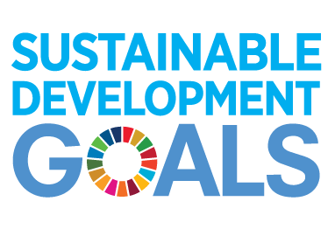
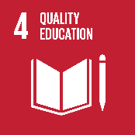
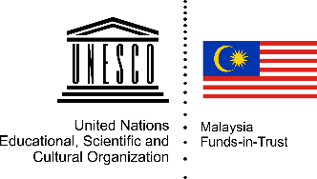
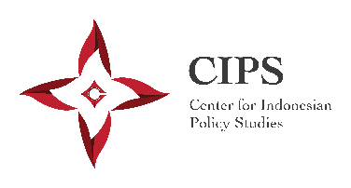

Source of Reading Materials
in the order of the booklet, each document separated by colored paper:

- UNESCO. (2017). A Guide for ensuring inclusion and equity in education. Available online: https://unesdoc.unesco.org/ark:/48223/pf0000248254
Part 1 Inclusion and equity in education p.12 – 13
- UNESCO. (2015). Analytical Framework for Inclusive Policy Design: Of what, why and how. Available online: https://en.unesco.org/inclusivepolicylab/analytics/analytical-framework-inclusive-policy-design
Full document
- AusAID. (2012). Australia-Indonesia Partnership for Pro-Poor Policy: The Knowledge Sector Initiative Design Document. Available online:
https://dfat.gov.au/about-us/publications/Documents/indo-ks-design.pdf
Chapter 1: “Understanding Indonesia’s Knowledge Challenge” p.1 – 21
- CIPS & UNESCO. (2018). Valorizing Research and Evidence for Social Inclusion in Indonesia: A Situational Analysis of the Current Information Uptake in Education Policymaking.
- CIPS & UNESCO. (2018). Valorizing Research and Evidence for Social Inclusion in Indonesia: A Practical Guide for Information Uptake in the Indonesian Education Policymaking Process.

