Valorizing Research and Evidence for Social Inclusion in Indonesia:

A Practical Guide for Information Uptake in the Indonesian Education Policymaking Process

December 2018

This document is produced under the framework of “Valorizing Evidence on Inclusive Social Development to Achieve the Sustainable Development Goals” Project, funded by the Malaysia Funds in Trust under the Malaysia – UNESCO Cooperation Programme (MUCP)

Content | Page
Abbreviations | 3
Introduction | 5
1. Why evidence-based decision making? | 6
2. What evidence should be part of the inclusive education policymaking process? | 12
3. Where is the evidence for the inclusive education policy design? | 17
4. How can evidence be used for inclusive education policies? | 22
Summary | 27
References | 30

Abbreviations

ACDP | Analytical and Capacity Development Partnership
APC | Asia Philanthropy Circle
Bappeda | Regional Planning and Development Agencies (Badan Perencanaan Pembangunan Daerah)
Bappenas | National Planning and Development Agency (Badan Perencanaan Pembangunan Nasional)
BPS | Statistics Indonesia/Central Bureau of Statistics (Badan Pusat Statistik)
CIPS | Center for Indonesian Policy Studies
CSO | Civil Society Organizations
CSR | Corporate Social Responsibility
Dapodik | Fundamental Education Data (Data Pokok Pendidikan)
DPR | People’s Representative Council (Dewan Perwakilan Rakyat)
EMIS | Education Management Information System
FPPS | Advocacy Forum for Sumba Education (Forum Peduli Pendidikan Sumba) in Sumba, East Nusa Tenggara Province
ICPA | International Centre for Policy Advocacy
KSI | Knowledge Sector Initiative
MOCI | Minister of Communication and Informatics
MOEC | Ministry of Education and Culture
MORA | Ministry of Religious Affairs
MORTHE | Ministry of Research, Technology and Higher Education
MOST | Management of Social Transformations Program
Musrenbang | Multi Stakeholder Consultation Forum for Development Planning (Musyawarah Rencana Pembangunan)
NTT | East Nusa Tenggara Province
ODI | Overseas Development Institute
PAUD | Early Childhood Education (Pendidikan Anak Usia Dini)
PD-DIKTI | Higher Education Database (Pangkalan Data Pendidikan Tinggi)
PEMANDU | Malaysian Government’s Performance Management and Delivery Unit
PIP | Smart Indonesia Program (Program Indonesia Pintar)
RCT | Randomized Control Trials
SD | Primary School (Sekolah Dasar)
SDG | Sustainable Development Goals
SLB | School for Children With Special Needs (Sekolah Luar Biasa)
SMP | Junior High School (Sekolah Menengah Pertama)
SMA | Senior High School (Sekolah Menengah Atas)
SMK | Vocational School (Sekolah Menengah Kejuruan)
SUSENAS | National Socio-economic Survey (Survei Sosial Ekonomi Nasional)
UNESCO | United Nations Educational, Scientific and Cultural Organization

Introduction

This project, concerning the valorization of evidence in inclusive social development in Southeast Asia, is part of UNESCO’s Inclusive Policy Lab work in the ‘Management of Social Transformations’ (MOST) Programme framework. The objective of the Lab is to support UNESCO Member States as they advance their social policy agendas by making better use of scientific information and knowledge—valorization refers to this process. The Lab aims to improve the South-South sharing of inclusive policy knowledge and practice, increasing availability of policy knowledge and advice in the region, and strengthening social data literacy among policy practitioners and other relevant stakeholders.

The UNESCO-Jakarta Office, in collaboration with the Center for Indonesian Policy Studies (CIPS), is implementing the project in Indonesia. Stage 1 of the cooperation between UNESCO and CIPS provided a situational analysis of inclusive policy design and knowledge valorization in the Indonesian education sector.

This practical guide constitutes stage 2 of the project and provides recommendations for Indonesian stakeholders to improve inclusivity in education policymaking processes. We recommend practical actions to improve the valorization of knowledge, that is, the availability, accessibility and usage of evidence in education policymaking processes. Our recommendations are meant to improve inclusivity and to support the national policy objective of providing access to quality education for all.

The main stakeholders addressed by this guide are the relevant government agencies in the Indonesian education sector, in particular the Ministry of Education and Culture (MOEC), bi- and multilateral donor agencies, and civil society organizations (CSOs). The recommendations focus on enhancing opportunities found by analyzing MOEC Regulation No. 142/2014, which specifies the steps of planning, drafting, discussion, legalization, and enactment of ministerial regulations by MOEC. The recommendations further include actions to improve the use of evidence on the side of bi- and multilateral donors and CSOs with the aim of achieving inclusive and equitable education in Indonesia.

1. Why evidence-based decision making?

In this part we argue that evidence-based decision making is an inevitable and indispensable part of inclusive policymaking and has practical implications for the work of stakeholders involved in the Indonesian education sector.

Evidence-based decision making makes evidence the base of decisions about policies, programs, and projects, in contrast to opinion-based decisions, which may use evidence selectively and be inspired by ideological standpoints or prejudices. Some observers see that the more speculative opinion-based policymaking is being replaced by evidence-based decision making, as illustrated in Figure 1.

Figure 1: The Dynamics of Evidence-based Policy
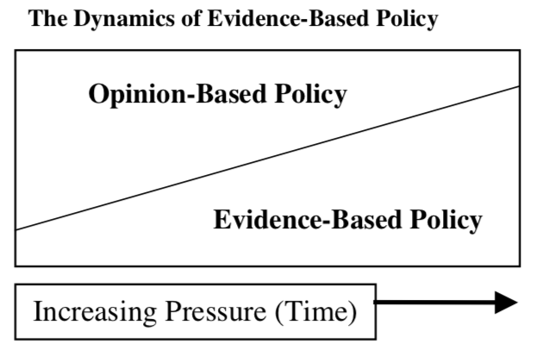
Source: Davies, 2004, adapted from Muir Gray, 1997

This is not to say that research for evidence-based decision making is necessarily neutral. It may be shaped by the political context or the values of those involved. It is therefore necessary to use a broad spectrum of evidence in evidence-based decision making and to follow a systematic approach that identifies and analyses the appropriate evidence in the policymaking process.

Davies identifies several types of evidence that are commonly generated through policy research (2004). The International Centre for Policy Advocacy (ICPA) summarized them as follows (Young and Quinn, 2012, p. 31):
- Impact evidence (reviewing effectiveness)
- Implementation evidence (determining effectiveness of implementation and delivery)
- Descriptive analytical evidence (measuring the nature, size, and dynamics of problems, populations, and so on)
- Public attitudes and understanding (via methods such as opinion polls or focus groups)
- Statistical modeling (linear and logarithmic regression methods to make sound predictions)
- Economic evidence (cost-benefit/cost effectiveness of policies)
- Ethical evidence (social justice, redistribution, winners and losers).

The complexity of the required evidence adds to the highly complicated context in Indonesia. The country has the fourth largest population in the world, with hundreds of ethnicities and languages spread over thousands of islands. Government Regulation No. 25/2000 concerning Central and Provincial Government Authorities as Autonomous Regions decentralized the government authority and split it between the central and regional governments. In the education sector, the central government sets the vision, main policies and standards of national education, while regional governments are authorized to implement policies and programs enacted by the central government through providing, maintaining, and monitoring education implementation in their jurisdiction. Regional governments are also authorized to adjust existing education policies in their respective regions by, for example, developing and evaluating local curricula or providing, distributing, maintaining, and monitoring educational facilities and infrastructure.

Given this enormous complexity, the evidence-based decision making process requires evidence from multiple sources. It must draw data and information from research as well as the experiences of stakeholders in central and regional governments, in bi- and multilateral donor agencies, and in civil society organizations.

The inclusion of data and information from many stakeholders is particularly important in education policy because to the importance of education for individual income opportunities, social mobility, the development of cognitive skills, and the ability to acquire the skills necessary for the 21st century. Education is particularly complex and education achievements depend on a wide range of factors (socio-economic status, the family structure, the type of school, absences, gender, ethnicity, geographical location, and dwelling types (Considine, G. and G. Zappalá, 2002)). In other words, education depends on economic development levels, the social context, ethnic and cultural influences, specific local circumstances, and trends that affect individual preferences.

Many stakeholders operate in Indonesia and maintain data and information that are useful for the evidence-based decision making process. The Indonesian government continuously professionalizes the generation of its main statistics. Statistics Indonesia (BPS), several ministries, and other government agencies generate highly relevant, useful data for the policymaking process. Despite some remaining limitations, through the use of information technology the ministries are revolutionizing the Indonesian data management system by allowing constant updates and wider access by all stakeholders.

Several bi- and multilateral donors provide information that supports the Indonesian government. This information is usually demanded by the government through agreements established between the Indonesian and foreign governments or between the Indonesian government and bi- and multilateral donors. Before implementing programs, bi- and multilateral donors hold discussions with the government on potential projects to determine what data are needed by the government and what interventions are needed to provide the data. This close cooperation continues for the duration of the project.

Table 1: Ten largest providers of foreign aid to Indonesia in 2012
Donor name | Country of Origin/Type | Amount provided (millions USD)
Asian Development Bank | Int’l organization | 886
World Bank | Int’l organization | 706
Japan International Cooperation Agency | Japan | 662
AusAID | Australia | 521
Global Fund | Int’l organization | 411
Agence Française de Développement | France | 192
USAID | United States | 180
United Nations | Int’l organization | 160
Millennium Challenge Corporation | United States | 120
Bundesministerium fuer wirtschaftliche Zusammenarbeit und Entwicklung | Germany | 116
Source: adapted from Dugay (2012)

Finally, Indonesia has a vibrant civil society comprising of thousands of CSOs operating across policy fields, including health, education, gender, income, entrepreneurship, and influence the policymaking process. These stakeholders are private Indonesian organizations. The majority of CSOs are not for-profit, relying largely on grants and donations to fund their programs. The larger ones engage on a relatively large scale (multi-province programs), while smaller CSOs focus their activities in specific regions. Think tanks and research institutes, such as the Center for Indonesian Policy Studies (CIPS) and the Smeru Research Institute, focus on research and evidence-based policy advice. Government stakeholders, bi- and multilateral donors, and CSOs all generate data that should be used for the systematic analysis of the evidence-based policymaking process. All stakeholders have their own strengths and limitations. They follow their particular interests, procedures, and internal incentives, all of which shape their particular approach to policymaking.

Given the dual complexities of the many types of evidence and the Indonesian context, only the use of data and evidence by all stakeholders can support a systematic approach, and a systematic approach is necessary for the evidence-based decision making process. Only a systematic approach that uses all available data in a thorough and transparent analysis—in other words, only the valorization of all knowledge provided by a broad range of stakeholders—can lead to an inclusive policy design process.

An education policy design that aims to include all learners, irrespective of their circumstances, needs to be multi-dimensional, relational, contextual and multi-layered, dynamic, and participatory and must intersect various risks and drivers that may amplify these risks. In other words, the policymaking process needs to fulfill all six dimensions of the UNESCO Analytical Framework for Inclusive Policy Design (UNESCO, 2015).

Inclusive policy design can make it possible for Indonesia to attain inclusive education, which, according to UNESCO International Bureau of Education Director Clementina Acedo, is seen as “’a process of addressing and responding to the diversity of needs of all learners through increasing participation in learning, cultures and communities, and reducing exclusion from education and from within education.’ The goal is that the whole education system will facilitate learning environments where teachers and learners embrace and welcome the challenge and benefits of diversity. Within an inclusive education approach, learning environments are fostered where individual needs are met and every student has an opportunity to succeed” (Acedo, 2008).

A core component of inclusive education policy design in Indonesia is the guideline for making a ministerial regulation in the Ministry of Education and Culture (MOEC). It follows the Regulation of the Indonesian Minister of Education and Culture (Permendikbud) No. 142/2014 (MOEC 142/2014) on the Formulation of Regulations under the Authorization of the Minister of Education and Culture. MOEC 142/2014 specifies the steps of planning, drafting, discussion, legalization, and enactment as illustrated in Figure 2 below.

Figure 2: Policy Design Process by the Ministry of Education and Culture

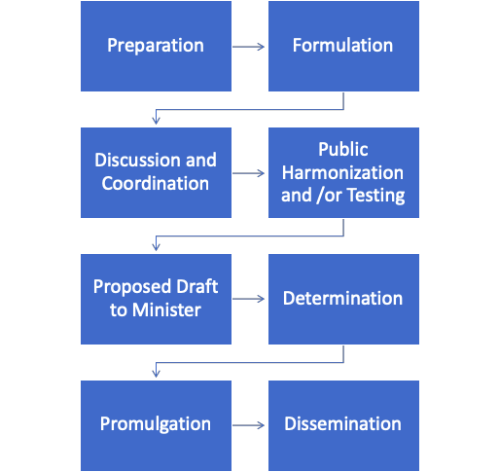
Source: MOEC Regulation No. 142/2014

The process allows for the inclusion of evidence from external stakeholders in step 1 (preparation) as well as step 3 (discussion and coordination with other government departments) and step 4 (public testing involving other stakeholders).

A positive example for inclusive policy design is the establishment of the Advocacy Forum for Sumba Education (Forum Peduli Pendidikan Sumba/FPPS) in Sumba, East Nusa Tenggara (NTT) Province. FPPS is a local government policy consultation and coordination forum established in June 2016 in Sumba, NTT. It was established in response to school case studies conducted by the Education Sector Analytical and Capacity Development Partnership (ACDP) team.

FPPS consists of representatives of all four districts in Sumba (West Sumba, Southwest Sumba, East Sumba, and Central Sumba). Representatives include the vice regents (Wakil Bupati), the heads of regional education offices (Dinas Pendidikan), and the heads of regional planning and development agencies (Bappeda). The aim of FPPS is to improve the quality of education in Sumba, with a particular focus on primary school education issues (ACDP, 2016, p.ix).

Recommendations:

- MOEC 142/2014 should be applied with a systematic approach that includes a broad range of evidence from stakeholders in the education sector. This can be done through regular forums, in which main education policies are discussed with experts and stakeholders. Forums can be inspired or built on the example of Musrenbang (Musyawarah Rencana Pembangunan or Multi Stakeholder Consultation Forum for Development Planning), a participatory, bottom-up consultation that feeds into the government’s annual planning.
- In its agreements with bi- and multilateral donors, the Indonesian government should recommend the horizontal coordination of education policies among regional governments, following the positive example of the Advocacy Forum for Sumba Education (Forum Peduli Pendidikan Sumba/FPPS) in Sumba, East Nusa Tenggara (NTT) Province.

2. What evidence should be part of the inclusive education policymaking process?

Since the importance of evidence-based decision making for an inclusive education policymaking process in Indonesia has been established, we will now turn to the selection of different types of evidence in policymaking.

The OECD separates the data used to craft education policies into three areas: a) data on the output and outcomes of education institutions and the impact of learning; b) indicators for the access to education as well as participation and progression within education entities; and c) input indicators, including financial resources invested in education, human resources such as teachers, and physical resources that shape the learning environment and the organization of schools (OECD, 2018, p.14).

Evidence refers, on one hand, to quantitative data, such as demand, supply, and use of available places in schools, the volume and allocation of funds, the background of children, student-teacher ratios and class sizes, and staff qualifications. These data are important for understanding access, participation, school leadership, equity (based on socio-economic status, migrant background, special needs, gender, and the digital divide), the quality of education provision, and economic and social outcomes. On the other hand, qualitative data that are harder to grasp numerically can still provide valuable evidence for policymaking. Qualitative data include educational trends over time, traditional responses to formal education, cultural and perception factors, and parental expectations.

The UNESCO Analytical Framework For Inclusive Policy Design identifies specific features of evidence that are particularly important. Evidence needs to be equity-weighted to include needs of the deprived and to detect and track disparities (both inter- and intra-group). This includes longitudinal and historical analysis. In the culturally and economically diverse society of Indonesia, evidence needs to be multidimensional and multidisciplinary, which means it needs to go beyond ‘measuring’ inequality and address the intersection of economic, social, cultural, political, and spatial factors. Evidence needs to use innovative combinations of qualitative, participatory, and quantitative methods and it has to be integrated across levels of governance, types of actors, sectors and time. Finally, it should be relevant to early stage and preventive action, in other words it should be appropriate for early-stage and/or preventive policy action (UNESCO, 2015).

The first step of the policymaking process regulated by MOEC 142/2014 is a systematic research review (Naskah Akademik), which requires a meta-analysis based on a substantial number of robust primary studies. These primary studies are conducted by research experts and include single case studies, case control studies, cross-sectional studies, cohort/longitudinal studies, quasi-experimental design, and randomized control trials. However, evidence also includes personal anecdotes and service-use feedback. While these methods are not scientific and personal anecdotes are hard to verify while in service-use-feedback the correlation between satisfaction and service effectiveness is low (NESTA and Alliance for Useful Evidence, 2016), they can still provide valuable insights.

The critical question is which evidence to use when designing a particular policy. It requires a clear understanding of the specific needs of the policy and of how to critically assess the relevance and quality of evidence.

Verifying the quality of the evidence used in the MOEC 142/2014 research review poses serious challenges. Peer-reviewed studies have received the approval of experts, but not all quality research is peer-reviewed. The Ministry could follow the classification of research quality used in medical research. Because medical science demands the highest quality work, it is among the most rigorously observed research areas and serves as a common benchmark for the quality of applied research tools.

Medical science ranks research methods starting with the highest quality, which has the best at the top with a well-conducted filtering of available information. This is done through a systematic research review that relies on the quality of the primary data, or unfiltered information. The best primary data come from suitably powered randomized control trials (RCT), followed by well conducted but small and under-powered RCT, non-randomized observational studies, non-randomized studies with historical controls and finally, at the very bottom, case series without controls (NESTA and Alliance for Useful Evidence, 2016, adapted from Bagshaw and Bellomo, 2008, p.2). The medical science evidence ranking system is illustrated in Figure 3.

Figure 3: Ranking levels of evidence in medicine
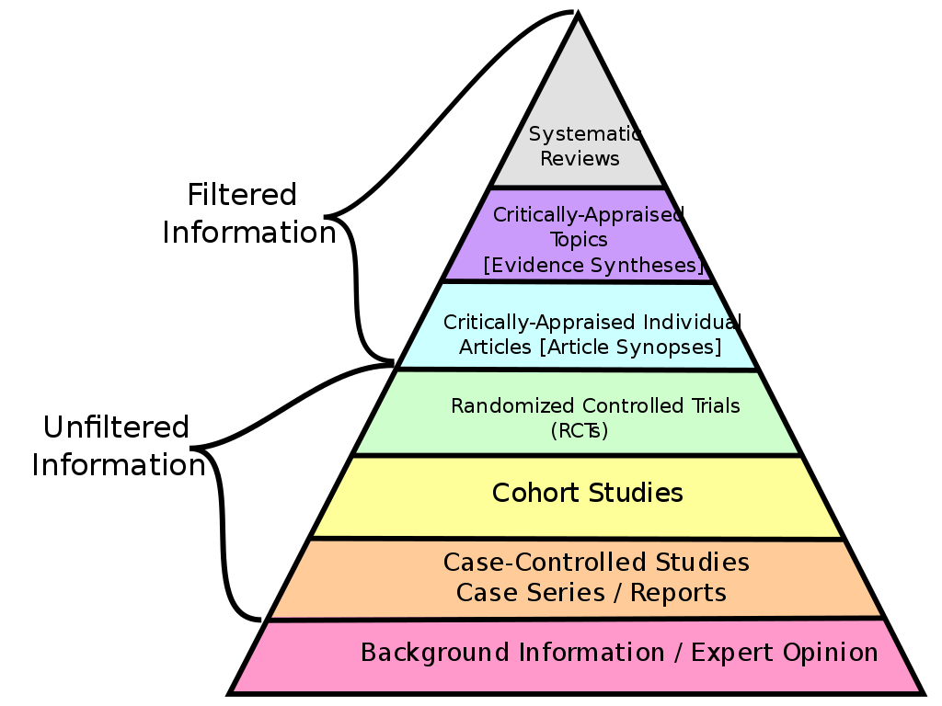
Source: Hugel, 2013

Choosing the highest quality evidence for policymaking requires suitable analytical capacity among decision makers, but the Knowledge Sector Initiative established that “formal policy processes featured actors primarily from the executive arm of government, usually appointed for their experience and seniority rather than their analytical skills.” (Bappenas, Knowledge Sector Initiative, Australian Government, 2018, p.v) If that is the case, then special importance must be applied to step 4 of MOEC 142/2014, that is, to public testing.

Public testing aims to analyze the response of affected stakeholders to a proposed regulation by conducting online presentations, seminars, and/or focus group discussions with audiences restricted to the affected stakeholders. The results are reported to the Minister of Education.

In some cases, MOEC tests regulations through pilot implementation, which is done by implementing a draft policy within a limited scope (i.e. in several schools, in certain regions). A new early childhood education (PAUD) policy, for instance, was implemented in some sample PAUD institutions first in order to evaluate and improve the drafted policy. Testing can take place up to three times before the regulation proceeds to the next stage of policymaking. Moreover, the use of modern communication technology, such as WhatsApp or Twitter, cuts through bureaucracy by enabling beneficiaries to communicate directly with policymakers, reporting issues and problems—provided they know how to reach decision making levels in MOEC.

The results of insufficient testing are illustrated by the problems with implementing Law No. 14/2005 Concerning Teachers and Lecturers. This law was the most comprehensive strategy to date for improving Indonesian teacher quality, forming the basis of a massive national teacher certification program in the last decade. The policy established standard qualifications for teachers and lecturers to become eligible for teaching in formal Indonesian education institutions and also regulated financial incentives for qualified teachers and their assignment to remote regions in Indonesia. Qualified teachers became entitled to double their base salaries, while teachers assigned to remote regions were entitled to receive additional allowances of up to three times their base salaries. These incentives were meant to attract teacher participation in a nationwide teacher certification program. In the end, however, while the law may have successfully improved teachers’ welfare it did not achieve its overarching goal of improving students’ performance (Suryadarma & Jones, 2013). The Minister of Finance stopped the disbursement of additional allowances in 2018.

The People’s Republic of China follows good public testing practices. China is similar to Indonesia in that it is a large country with large provinces in which new policies can be tested. It is widely acknowledged that China’s capability to generate institutional and policy innovations is the result of decentralized experimentation. Though its different political system makes a wholesale adoption of the Chinese process impossible, there are important lessons that can be learned from the Chinese experience.

In China’s policymaking process, central policy makers encourage local officials to try out new ways of problem solving and then report on local experiences so that the information can be fed back into national policy formulation. According to political scientist and sinologist Prof. Sebastian Heilmann, “this has been a pervasive feature in China’s socio-economic transformation.” (Heilmann, 2008) China’s decentralized experimentation has often tested significant policies in selected provinces over a period of several years, systematically analyzing the policy’s impact with the option to discontinue if it does not achieve the desired results.

Recommendations:
- At step 1 of MOEC 142/2014, when MOEC is preparing its literature review, Naskah Akademik, education experts with the analytical skills to recognize quality evidence that is relevant to the policy being considered should be commissioned to choose the evidence to include.
- An adaptation of the Chinese experience of policy testing to the public testing in step 4 of MOEC 142/2014 in the Indonesian context could improve the testing of particularly significant or large-scale policies, such as restructuring teacher incentives. MOEC already tests the rollout of certain policies in selected districts before applying it nationwide. It is recommended that, learning from the policymaking process in China, these tests should become more long-term, well researched, and open-ended with regard to the final adoption of the respective policy nationwide.

3. Where is the evidence for the inclusive education policy design?

Broad evidence is needed for inclusive education policy design. This section identifies where that evidence is generated and maintained in Indonesia and what can be done to improve the management to this data.

At the central level, government acts in separate agencies so even here data and information are generated and held across various agencies. Information related to primary and secondary formal (i.e., SD, SMP, SMA/SMK) and non-formal (i.e., PAUD, Package A,B,C) education systems are recorded in MOEC, while information related to Islamic education (i.e., Madrasah and Pesantren) is available within MORA, specifically within the Directorate General of Islamic Education. MORTHE keeps data and information related to formal tertiary education.

The central government maintains online databases of schools’ detailed information, including their location and the number of students and teachers. Schools under MOEC use the Fundamental Education Data (Data Pokok Pendidikan / Dapodik) database, while schools under MORA use the Education Management Information System (EMIS). MORTHE institutions report to the Higher Education Database (Pangkalan Data Pendidikan Tinggi / PD-DIKTI). These government databases are managed independently by the respective schools and other learning institutions and allow for continuous updates of data and information.

MOEC operates on the sub-national level through local offices (Dinas Pendidikan), which are work units of MOEC at the regency/city level (Government Regulation No. 32/2004 concerning Regional Government, Law No. 20/2003 concerning National Education System). These offices allow MOEC to operate locally and to supervise the collection of data from schools.

In addition, the national statistics agency Statistics Indonesia (BPS) publishes an annual Education Statistics report containing information about the Indonesian education sector. The data include several key indicators of educational processes and achievements (including the number of schools, students, teachers, and educational infrastructure) based on the results of national socio-economic surveys (Susenas) as well as school registration data collected by the relevant Ministries. BPS maintains data on illiteracy rates and school participation as well as dropout rates at the formal and non-formal education levels (Package A is non-formal education equivalent to elementary school, package B is equivalent to junior high school and package C is equivalent to high school).

Data maintained by government agencies such as BPS, MOEC and MORA are a key source of information for policymakers and are frequently used for policymaking purposes. In one instance, the national parliament (DPR) and MOEC used available and accessible information about student dropout rates from BPS to map priority regions when formulating and implementing the Smart Indonesia Program (Program Indonesia Pintar / PIP).

The enactment of Government Regulation No. 25/2000 concerning Central and Provincial Government Authorities as Autonomous Regions decentralized authorities and split them between the central and regional governments, changing the governing structure of the public education system in Indonesia. The central government sets the vision, main policies, and standards for national education. Regional governments are authorized to implement policies and programs enacted by the central government through providing, maintaining, and monitoring education provision in their jurisdiction. Regional governments are also authorized to adjust existing education policies in their respective regions by, for example, developing and evaluating local curricula or providing, distributing, maintaining, and monitoring educational facilities and infrastructure. All regional governments, therefore, maintain evidence on local education, but only some also publish annual reports and make them available online through their own respective websites.

The above-mentioned Advocacy Forum for Sumba Education (FPPS), which aims to improve the quality of education in Sumba, with a particular focus on primary school education, uses a good practice. FPPS consists of representatives of all four districts in Sumba (West Sumba, Southwest Sumba, East Sumba, and Central Sumba). Representatives include the vice regents (Wakil Bupati), the heads of regional education offices (Dinas Pendidikan), and the heads of regional planning and development agencies (Bappeda). FPPS’s main tasks include: (1) galvanizing coordinated actions in areas where all districts have common problems and interests; (2) monitoring the commitment of all districts in implementing policy reforms within their jurisdiction; and (3) ensuring the compliance of all districts in submitting their progress reports on policy adoption, resourcing, and regulating (ACDP, 2016, p. xi).

Education is one of the target sectors for foreign aid to Indonesia. An additional source of evidence is therefore data generated by the bi- and multilateral donor agencies that operate in the Indonesian education sector. Donors are able to provide information demanded by the government through the agreements governing their projects and the discussions held with governments in the planning stages, as discussed in section 1.

Data held by bi- and multilateral donors include information on the demand and supply sides of education, the use of available places in schools, volume and allocation of funds, the background of children, student-teacher ratios and class sizes, and staff qualifications. These data can provide important information about access, participation, school leadership, equity (based on socio-economic status, migrant background, special needs, gender, and the digital divide), the quality of provision, and economic and social outcomes.

Due to donors’ focus on targeted regions, their operations are often conducted through field offices using a generally results-oriented, effective management structure. Because of this, donors are able to assess the achievements of particular policies, programs, or projects. Due to their often long-term engagement, they can generate longitudinal research in which data is generated over years, allowing them to observe more complex issues, such as general trends over time and the influence of cultural and perception factors.

Evidence from bi- and multilateral donors accumulates mostly within their own intervention areas in the Indonesian sector. These include: curriculum, content, and pedagogy, vocational education, school governance, supporting education reform, education research, school leadership development, finance, teacher quality, early childhood intervention, cultural and perception factors, supply of infrastructure, technology, building entrepreneurship skills, and teaching and learning environment (APC, 2017, pp. 89-97).

Due to their close cooperation with the Indonesian government, donor data are used for policy development purposes. For instance, MOEC asked USAID to analyze teacher deployment schemes to help the government improve the efficiency of the system. Another example of the usage of evidence can be found in the implementation of a fingerprint-based system for recording the attendance of teachers in class. Based on research released in 2014 by ACDP on teachers' absenteeism, a recommendation was issued to use a fingerprint system to record teachers' attendance. Following this recommendation, public schools nationwide have implemented the fingerprint attendance system to accurately record teachers’ attendance in school. Teachers’ remuneration can be accurately calculated according to the record system and violation of working hours can be more easily identified. Based on the MOEC regulation (Permendikbud) No. 15/2018, regional Ministry offices (Dinas Pendidikan) are given the task to supervise the system.

A third major source of evidence is provided by civil society organizations (CSOs) engaged in Indonesia’s education sector. A recent study conducted by the Asia Philanthropy Circle with the analytical support of McKinsey & Company and AlphaBeta Advisors provided a comprehensive overview of philanthropic interventions for inclusive education in Indonesia (APC, 2017). Besides bi- and multilateral donors, the study also provides information on foundations, think tanks, non-profits and social enterprises, private sector CSR, and education technology (EdTech).

Foundations are usually set up by individuals, groups of individuals, or companies. They operate in specific geographical areas, often over years, and focus on particular aspects of education. In these areas they hold considerable expertise and are able to compile useful evidence. Foundations are predominantly involved in efforts to improve teacher quality, the supply of education infrastructure, early childhood interventions, curriculum, content and pedagogy, and vocational education (APC, 2017, pp. 83-89).

Private sector CSR and education technology providers mostly operate in the areas of education technology (APC, 2017, pp. 103-107). Non-profits and social enterprises engage mostly in programs for improving teacher quality, as well as curriculum, content, and pedagogy (APC, 2017, pp. 98-103). Finally, think tanks generally focus on education research and supporting education reform (APC, 2017, pp. 97-98).

Think tanks or research institutes can hold high quality evidence that can be used in the policymaking process. Some cooperate with government agencies and with bi- and multilateral donors to undergo the required analysis of education interventions, but all foundations and other CSOs have valuable information that should also be accessible for the inclusive education policymaking process.

Recommendations:
- MOEC and MORA maintain education databases that are regularly updated by the schools themselves. Due to limitations such as limited technological ability and undelivered instructions, these government databases are incomplete. For example, the majority of Islamic schools (Pondok Pesantren) have not been properly recorded in EMIS despite being education institutions under the responsibility of MORA. It is recommended that MOEC and MORA conduct regular capacity building training for school administrators, conveying clear instructions how to update the required data.
- Separate databases that are maintained by different ministries pose a challenge to establishing a holistic system of data management that avoids and eliminates errors and contradictory information. It is recommended that MOEC and MORA consider a single, integrated database as both address basic education levels. This single database should be constructed along the lines of an ideal Education Management Information System as outlined by UNESCO, “the ensemble of operational processes, increasingly supported by digital technology, that enable the collection, aggregation, analysis, and use of data and information in education planning, monitoring and evaluation, policy analysis, and decision making” (Subosa and West, 2018, pp. 8 and 26).
- In Indonesia only some provincial governments publish annual reports and make them available online through their own respective websites. It is recommended that MOEC influences all provincial governments to compile and publish annual education reports through its local offices (Dinas Pendidikan).

4. How can evidence be used for inclusive education policies?

To get the evidence into inclusive education policymaking requires the efforts of both the sender who has evidence to share and the recipient who needs the evidence for the decision making process.

The “knowledge-to-policy model” by the Knowledge Sector Initiative contains four inter-connected pillars (AusAID, 2012): a) the supply side of evidence; b) the demand side; c) policies, regulations and procedures for the uptake of evidence in the policymaking process; and d) the intermediary functions and bodies that translate, package and communicate knowledge. In reality, it is often the supply side that needs to take care of these intermediary functions.

The supply side produces knowledge and evidence that influences policies, while the demand side uses evidence in formulating policies. Policies, regulations, and procedures to govern the uptake of evidence in the policymaking process are mostly set on the demand side. Intermediary functions and bodies that translate, package, and communicate knowledge fall usually within the responsibility of the supply side of evidence.

On the demand side, there is MOEC, which has defined a process for the uptake of evidence in ministerial regulations through MOEC 142/2014. The entire cycle of policymaking contains eight steps (outlined in section 1), of which three are concerned with the uptake of evidence from other organizations. Step 1 (preparation) focuses on data from Statistics Indonesia and internal ministerial sources such as the Education Statistics Data Center, but also includes accessible data from other stakeholders, such as CSOs and bi- and multilateral donors. Step 3 (discussion and coordination) allows coordination and sharing information with other government departments while step 4 (harmonization and testing) allows the gathering of information from affected stakeholders. Recommendations have been made above for revised practices in these steps to improve their effect on inclusive education policy design.

On the supply side, there are government agencies, bi- and multilateral donors, and CSOs. Bi- and multilateral donors and their local partners make the evidence gained through their projects available to users. Most data are available in various documents and formats in the form of processed data. Raw data, such as survey results, statistics, figures, and numbers, are usually not readily available through donors’ websites. They can be granted by request unless the provision of data is restricted by the Minister of Communication and Informatics (MOCI) regulation regarding Personal Data Protection in Electronic Systems (MOCI Regulation No. 20 of 1 December 2016). All information is copyrighted, but it can generally be reproduced in whole or in part for non-commercial purposes with proper attribution.

MOEC has good access to evidence from bi- and multilateral donors. In the case of the Analytical and Capacity Development Partnership project that was funded by the Australian government and the European Union, MOEC established an agreement with the project through which it requested information. The project gathered the required information through research, usually involving CSOs as contractors. The output of the research was delivered in form of research reports and policy papers. Prior to delivering the information to the Ministry, ACDP evaluated the output to ensure quality and reliability of the information.

The majority of CSOs engaged in inclusive education programs and policies have joined an initiative of the Asia Philanthropy Circle (APC) in 2017 to inventory and possibly coordinate their interventions in the future. The APC study came to the sobering conclusion that “more than 60 percent of the interventions studied are micro-scale, impacting less than 1 percent of the target group” (APC, 2017). As a result of discussions with relevant CSOs, APC suggested that philanthropists focus on four priority areas to catalyze change: teacher quality, school leadership and governance, vocational education, and early childhood education and development.

APC acknowledges that individual interventions can improve their effectiveness, “if the interlinked components of the education ecosystem are addressed in tandem” (APC, 2017). It calls on philanthropists to work together and with other stakeholders to catalyze broad-based change. This collaboration can take many forms, as shown in Figure 4.

Figure 4: Potential ways for philanthropists in Indonesia to collaborate

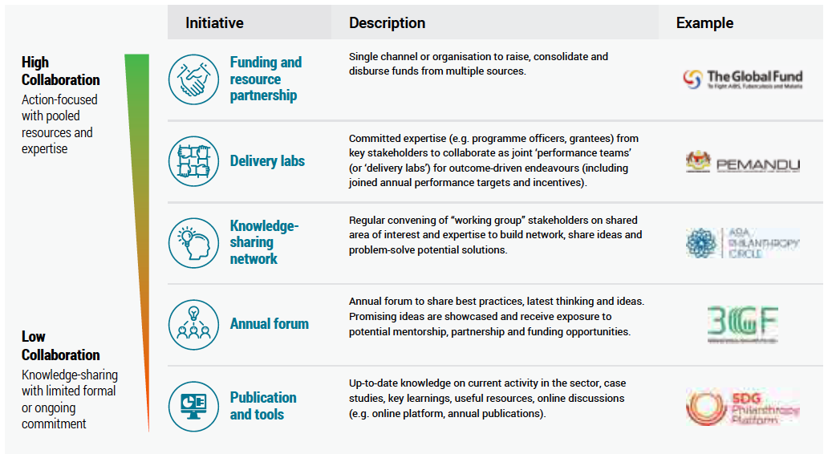
Source: APC – Asia Philanthropy Circle, Catalysing Productive Livelihoods. A guide to education interventions with an accelerated path to scale and impact, 2017

According to APC, a high level of collaboration can be achieved when philanthropists combine their funds into a significant resource pool to tackle large challenges. This claim is reinforced by the case in the Global Fund to fight AIDS, tuberculosis, and malaria. A joint fund in the Indonesian education sector could have a considerable impact on early childhood education and health topics, an area that APC sees as underfunded.

The next level of potential collaboration is the establishment of common facilities for institutions with similar goals, the approach used in teacher quality labs run by the Malaysian Government’s Performance Management and Delivery Unit (PEMANDU). APC is a knowledge-sharing network, which is seen as a mid-level of collaboration. Annual forums that showcase promising ideas are regarded as useful and, at the most basic level, philanthropists can use publications and other tools to keep up to date on trends and current initiatives in education (APC, 2017).

Practical and successful cooperation has emerged from a new APC-inspired communication between stakeholders in the education sector. Three philanthropic foundations introduced an interactive map of education interventions in Indonesia (https://www.asiaphilanthropycircle.org/edu-giving-guide-indonesia/interactive-map-indonesia-education-interventions/). The map allows institutions to share detailed information, pinpointing schools where these interventions took place with a GPS marker. The map includes information such as the names of institutions, the type of programs, site locations, and the level of education the programs focus on. This is an excellent example of a highly accessible database, in which information is updated by respective organizations, presented in a way that is comprehensible by users and easily accessible for public use. This available and accessible information also helps to inspire other interventions and to prevent education stakeholders from duplicating programs.

Still, it remains a challenge for CSOs to influence policymaking, and not only in the area of inclusive education policies. The British Overseas Development Institute (ODI) acknowledges that policymaking processes are generally complex and only weakly informed by research-based evidence. ODI concludes that researchers need to offer not only clear intent and persistence but also additional skills as policy entrepreneurs if they are to influence public policy. This refers, in particular, to researchers in independent institutions whose evidence has not been specifically requested by decision makers and does not automatically feed into the policymaking process. “They need to be good storytellers, able to synthesise simple compelling stories from the results of the research. They need to be good networkers to work effectively with all the other stakeholders, and they need to be good engineers, building a programme that pulls all of this together. Or they need to work in multidisciplinary teams with others who have these skills.”(ODI, 2009, p. 2)

In order to “translate, package, and communicate knowledge”, one of the four pillars of KSI’s knowledge-to-policy model, researchers-turned-policy entrepreneurs must master strategic management and communication. Strategic management skills have been laid out by ODI in their RAPID Outcome Mapping Approach (ROMA), which includes mapping the political context, identifying key stakeholders, identifying desired behavior changes, developing a strategy, analyzing the internal capacity to effect change, and establishing monitoring and learning networks (ODI, 2009, p. 3). In addition, CSOs need to improve their strategic communication skills in order to prepare their evidence in a language, format, and time that suits the policymakers and the policymaking process.

Recommendations:

- Problems with the availability of bi- and multilateral donors’ evidence for the policymaking process might occur after a project ends. Once the project teams have been dissolved and the local partners turn to other tasks and programs, raw data and analysis, as well as institutional memory, are at a risk of being lost. It is recommended that donor agencies consider long-term storage and online availability of all data at the outset of their respective projects. Raw databases should also be made available online where possible, password-protected with clear instructions who is eligible to access the data, for what purpose, and how to obtain the necessary password.
- CSOs should intensify their coordination and collaboration to maximize their impact on inclusive education policies, whether through something as simple as sharing information or as involved as pooling resources. A good process has been started by APC and all the organizations involved in their network of CSOs that are engaged in inclusive education programs and policies.
- At the end of 2018, 15 CSOs had entered data into the interactive map of education interventions in Indonesia. It is recommended that more CSOs share their data in (https://www.asiaphilanthropycircle.org/edu-giving-guide-indonesia/interactive-map-indonesia-education-interventions/).
- CSOs should undergo special training in strategic management and communications and to prepare their evidence in a language, format and time that suits the policymaking process in order to improve their ability to influence the policymaking process.

5 Summary

This practical guide has made several recommendations of how both the supply and the demand side of evidence can improve the valorization of knowledge, that is, strengthen the availability, accessibility, and usage of evidence in education policymaking processes. These recommendations are meant to improve inclusivity and support the national policy objective of providing access to quality education for all.

On the demand side, we have placed particular focus on MOEC 142/2014, which regulates the planning, drafting, discussion, legalization, and enactment of ministerial regulations by MOEC. Several recommendations were made to improve the uptake of evidence in the policymaking process.

On the supply side, recommendations were made regarding the main types of stakeholders: government agencies, bi- and multilateral donors, and civil society organizations. Practical recommendations to improve the provision of evidence for the policymaking process were offered.

In the final part of the cooperation between UNESCO and CIPS in this project, the recommendations will be shared with all stakeholders in a program that supports the capacity development within stakeholder organizations.

The recommendations are as follows:

- MOEC 142/2014 should be applied with a systematic approach that includes a broad range of evidence from stakeholders in the education sector. This can be done through regular forums, in which main education policies are discussed with experts and stakeholders. Forums can be inspired or built on the example of Musrenbang (Musyawarah Rencana Pembangunan or Multi Stakeholder Consultation Forum for Development Planning), a participatory, bottom-up consultation that feeds into the government’s annual planning.

- In its agreements with bi- and multilateral donors, the Indonesian government should recommend the horizontal coordination of education policies among regional governments, following the positive example of the Advocacy Forum for Sumba Education (Forum Peduli Pendidikan Sumba/FPPS) in Sumba, East Nusa Tenggara (NTT) Province.

- At step 1 of MOEC 142/2014, when MOEC is preparing its literature review, Naskah Akademik, education experts with the analytical skills to recognize quality evidence that is relevant to the policy being considered should be commissioned to choose the evidence to include.

- An adaptation of the Chinese experience of policy testing to the public testing in step 4 of MOEC 142/2014 in the Indonesian context could improve the testing of particularly significant or large-scale policies, such as restructuring teacher incentives. MOEC already tests the rollout of certain policies in selected districts before applying it nationwide. It is recommended that, learning from the policymaking process in China, these tests should become more long-term, well researched, and open-ended with regard to the final adoption of the respective policy nationwide.

- MOEC and MORA maintain education databases that are regularly updated by the schools themselves. Due to limitations such as limited technological ability and undelivered instructions, these government databases are incomplete. For example, the majority of Islamic schools (Pondok Pesantren) have not been properly recorded in EMIS despite being education institutions under the responsibility of MORA. It is recommended that MOEC and MORA conduct regular capacity building training for school administrators, conveying clear instructions how to update the required data.

- Separate databases that are maintained by different ministries pose a challenge to establishing a holistic system of data management that avoids and eliminates errors and contradictory information. It is recommended that MOEC and MORA consider a single, integrated database as both address basic education levels. This single database should be constructed along the lines of an ideal Education Management Information System as outlined by UNESCO, “the ensemble of operational processes, increasingly supported by digital technology, that enable the collection, aggregation, analysis, and use of data and information in education planning, monitoring and evaluation, policy analysis, and decision making” (Subosa and West, 2018, pp. 8 and 26).

- In Indonesia only some provincial governments publish annual reports and make them available online through their own respective websites. It is recommended that MOEC influences all provincial governments to compile and publish annual education reports through its local offices (Dinas Pendidikan).

- Problems with the availability of bi- and multilateral donors’ evidence for the policymaking process might occur after a project ends. Once the project teams have been dissolved and the local partners turn to other tasks and programs, raw data and analysis, as well as institutional memory, are at a risk of being lost. It is recommended that donor agencies consider long-term storage and online availability of all data at the outset of their respective projects. Raw databases should also be made available online where possible, password-protected with clear instructions who is eligible to access the data, for what purpose, and how to obtain the necessary password.

- CSOs should intensify their coordination and collaboration to maximize their impact on inclusive education policies, whether through something as simple as sharing information or as involved as pooling resources. A good process has been started by APC and all the organizations involved in their network of CSOs that are engaged in inclusive education programs and policies.

- At the end of 2018, 15 CSOs had entered data into the interactive map of education interventions in Indonesia. It is recommended that more CSOs share their data in (https://www.asiaphilanthropycircle.org/edu-giving-guide-indonesia/interactive-map-indonesia-education-interventions/).

- CSOs should undergo special training in strategic management and communications and to prepare their evidence in a language, format and time that suits the policymaking process in order to improve their ability to influence the policymaking process.

References

ACDP - The Education Sector Analytical and Capacity Development Partnership, (2016). Strategies for Improving Basic Education School/Madrasah Effectiveness in Sumba, NTT Volume 2: Knowledge to Policy. Jakarta: The Education Sector Analytical and Capacity Development Partnership (ACDP).

Acedo (2008). “Interview with the UNESCO-IBE Director, Clementina Acedo”, Available online: http://www.ibe.unesco.org/fileadmin/user_upload/Policy_Dialogue/48th_ ICE/Press_Kit/Interview_Clementina_Eng13Nov.pdf

APC – Asia Philanthropy Circle. (2017). Catalysing Productive Livelihood: A guide to education interventions with an accelerated path to scale and impact, Available online: https://www.asiaphilanthropycircle.org/edu-giving-guide-indonesia/

AusAID (2012). Australia-Indonesia Partnership for Pro-Poor Policy: Knowledge Sector Initiative Design Document, Available online: https://dfat.gov.au/about-us/publications/Documents/indo-ks-design.pdf

Bagshaw, S. M. and Bellomo, R. (2008), The need to reform our assessment of evidence from clinical trials: A commentary, Available online: https://peh-med.biomedcentral.com/articles/10.1186/1747-5341-3-23

Bappenas, Knowledge Sector Initiative, and Australian Government, (2018). “Policy, Change and Paradox in Indonesia: Implications for the Use of Knowledge,” Working Paper 29, Available online: http://www.ksi-indonesia.org/file_upload/ Policy-Change-and-Paradox-in-Indonesia-Implicati-06Feb2018172546.pdf

Considine, G. and G. Zappalá (2002), “Factors influencing the educational performance of students from disadvantaged backgrounds”, in T. Eardley and B. Bradbury, eds, Competing Visions: Refereed Proceedings of the National Social Policy Conference 2001, SPRC Report 1/02, Social Policy Research Centre, University of New South Wales, Sydney, pp. 91-107. Available online: https:// www.sprc.unsw.edu.au/media/SPRCFile/NSPC01_7_Considine_Zappala.pdf

Davies, P. (2004) Is Evidence-Based Government Possible? Conference Paper for the Campbell Collaboration Colloquium, Washington. Available online: https:// webarchive.nationalarchives.gov.uk/20091013084422/http://www.nationalschool.gov.uk/policyhub/downloads/JerryLeeLecture1202041.pdf

Dugay, C. (2012). Indonesia’s top 10 donors: Responding to the promise of transformation. Available online: https://www.devex.com/news/indonesia-s-top-10-donors-responding-to- the-promise-of-transformation-78905.

Government Regulation No. 25/2000 concerning Central and Provincial Government Authorities as Autonomous Regions (President) (Indonesia).

Government Regulation No. 32/2013 concerning the Revision of Government Regulation No. 19/2005 on National Education Standards (President) (Indonesia).

Heilmann, S. (2008). “From Local Experiments to National Policy: The Origins of China’s Distinctive Policy Process”, The China Journal. No. 59 (pp. 1-30), Available online: https://www.jstor.org/stable/20066378?seq=1 #page_scan_tab_contents

Hugel, K. (2013). The Journey of Research - Levels of Evidence. Canadian Association of Pharmacy in Oncology, Available online: https://www.capho.org/blog/journey-research-levels-evidence

Law No. 20/2003 Concerning National Education System (DPR) (Indonesia).

Law No. 14/2005 Concerning Teacher and Lecturer (DPR) (Indonesia).

MOCI Regulation No. 20/2016 Concerning Personal Data Protection in Electronic Systems (MOCI) (Indonesia).

MOEC Regulation No. 142/2014 Concerning Guidelines for Formulation of Minister of Education and Culture Regulations (MOEC) (Indonesia).

MOEC Regulation No. 15/2018 Concerning the Fulfillment of Principals’, Teachers’ and School Supervisors’ Workload (MOEC) (Indonesia).

Muir Gray, J.A. (1997) Evidence-Based Healthcare: How to Make Health Policy and Management Decisions, New York, Edinburgh, London: Churchill Livingstone.

NESTA and Alliance for Useful Evidence. (2016). Using Research Evidence. A Practical Guide, Available online: http://www.alliance4usefulevidence.org/assets/Using-Research-Evidence-for-Success-A-Practice-Guide-v6-web.pdf

OECD. (2018). Education at a Glance: OECD Indicators. Available online: http://dx.doi.org/10.1787/eag-2018-en.

Overseas Development Institute, (2009). “Helping researchers become policy entrepreneurs: How to develop engagement strategies for evidence-based policy-making,” Briefing Paper 53. Available online: https://www.odi.org/sites/ odi.org.uk/files/odi-assets/publications-opinion-files/1730.pdf

Subosa, M. and West, M. (2018). “Re-orienting Education Management Information Systems (EMIS) towards inclusive and equitable quality education and lifelong learning”. Working Paper on Education Policy 5. UNESCO, Available online: https://unesdoc.unesco.org/ark:/48223/pf0000261943_eng

Suryadarma, D., & Jones, G. (2013). Education in Indonesia (pp. 144-157). Singapore: Institute of Southeast Asian Studies (ISEAS)

UNESCO. (2015). Analytical Framework for Inclusive Policy Design, Available online: https://en.unesco.org/inclusivepolicylab/analytics/analytical-framework-inclusive-policy-design

UNESCO and CIPS. (2018). A Situational Analysis of the Current Information Uptake in Education Policymaking

Young, E. and Quinn L. (2012). Making Research Evidence Matter. A Guide to Policy Advocacy in Transition Countries, Open Society Foundations/International Centre for Policy Advocacy (ICPA), Available online: http://advocacyguide. icpolicyadvocacy.org/sites/icpa-book.local/files/Policy_Advocacy_Guidebook _2012.pdf

For a more detailed discussion of MOEC 142/2014 see UNESCO and CIPS. (2018) A Situational Analysis of the Current Information Uptake in Education Policymaking

