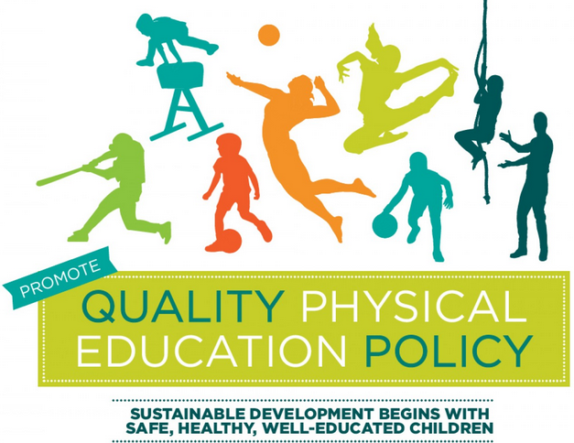
Grassroots stakeholders’ consultations Sub-Groups

Group | Inclusion | Teacher Training/Universities | Policy Collaboration | Research | PE & Community
Task | Please refer to Guidelines for Policy-Makers pages 32 to 41 with a checklist to eliminate barriers to inclusion page 41. | Please refer to Guidelines for Policy-Makers pages 50-53 with checklist to improve teacher education, supply and development on page 53. | 1. Critical evaluation and harmonization of relevant existing policies, links and gaps between various ministries and policies: School Policy, Health Policy, Sports Policy, Youth Policy and Child Policy.  2. Institutional capacity assessment, analysis of SWOTs, policy priorities, and policy alternatives. | 1. To develop plans for conducting research on PE to contextualize the content/methods of teaching PE in school.  2. Collaborating of research in higher learning institutions to fill the knowledge gaps in the industry (Ministries). | Please refer to Guidelines for Policy-Makers pages 42-48 with checklist to improve policy and practice on page 48.  Strategize on PE in schools and Community sports partnerships: how to link PE and community sports and use community and schools facilities to encourage PE and Sport beyond the School day.
Members | Mr. T. Ndonyo  Mr. S. Kapilima  Mr. W. Sikapanda  Mr. N. Banda.  Ms. M. Mwaba  Mr. S. Mwanangombe  Ms. Thanseka soko | Mr. L. Malambo  Mr. Siyanga  Mrs. Moonga  Mr. Kapansa  Cpt. Mutiti  Mr. S. Mayamba  Mr. C. Chileshe  Ms. M Nedziwe | Mr. Emmanuel Mali  Mr. C. Chileshe  Ms. Besa Chibwe  Major Kaonga  Mr. Oswell Nalacinda  Dr. Andrew Mutobo  Mr. M. Kalima  Mr. Mwango  Ms. Thandeka Soko  Mrs. Musakula  Mr. N. Banda  Ministry of Health?  Ministry of Youth? | Dr. Andrew Mutobo  Mr. S. Mayamba  Mr. Yumbe  Mr. Mulenga | Mr. F. Mushindu  Mr. C. Chileshe  Mr. Malanga  Mr. C Chama  Mr. E. Chanda  Mr. Muyale.

