On November 13th 2019, academics, activists, policymakers, and other stakeholders met at Thurgood Marshall Civil Rights Center, Howard University School of Law, Washington D.C. for the Mid-Decade Summit. The event focused on discussion of achievements made in the first five years of the International Decade for People of African Descent (2015-2024); and how to ensure the remainder of the Decade proved more fruitful for the African diaspora globally. With this in mind, the Agenda for the day featured three panels and three workshops, which were livestreamed online as well as engaging the live audience, with the primary objective of producing an outcome document, for IDPAD’s way forward in the remaining five years of the decade.
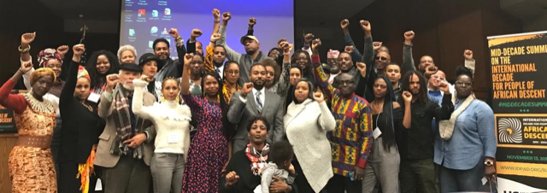
The first plenary Looking to the Past featured Afro descendant panellists from France, Belgium, Chile and the USA, who gave a review of progress made and problems encountered during the first half of the Decade, to raise awareness. In that regard, panellists expressed overwhelming dissatisfaction with the role played by state parties in implementing IDPAD, whilst some panellists gave account of achievements made within their regions that illustrate “our collective efforts are beginning to bear fruit”. A Q & A followed the first panel in which panellists responded to questions posed from the audience. For example, a representative of the European Network for People of African Descent clarified the European Parliament’s Resolution on the fundamental rights of People of African Descent and Black Europeans in Europe is an informal achievement, but remains a paper tiger with no teeth, because EU institutions do not formally implement the Resolution in practice.
The second plenary Planning for the Future followed in the form of “a moderated Town Hall discussion,” where participants addressed their vision for IDPAD moving forward; panellists included representatives of civil society, academia and public bodies from the UK, USA and Latin America. Highlighted themes included mass incarceration of Afro descendants globally, e.g. in the USA, Brazil and Columbia; it was therefore argued that it is necessary to push the African centred Agenda within other agendas such as the 2030 Agenda for Sustainable Development.
After Q & A, the third and final plenary focused on the issue of Reparatory Justice, which is a fundamental objective for IDPAD. In that regard, the Summit’s organisers identified the need for a transnational conversation around reparations for formerly enslaved and colonized Afro descendant peoples. North American and South American panellists agreed this to be the case given the overwhelming failure of state parties to fulfil their pledges and obligations, for implementation of IDPAD’s Programme of Action and thematic objectives of recognition, justice and development.

Following lunch, the final session of the Summit consisted of three facilitated workshops around the theme Using the Decade for people of African descent; these workshops were on the UN Permanent Forum for people of African descent, the UN Draft Declaration on the Rights of People of African Descent, and National Action Plans. The workshops entailed discussion with participants, to formulate concrete ideas for IDPAD to achieve successful outcomes for the African diaspora. In that regard, the workshop on the UN Permanent Forum set the context for that on the UN Draft Declaration on the Rights of People of African Descent, which in turn plays a role in developing National Action Plans.
The workshop on the UN Draft Declaration on the Rights of People of African Descent, which I facilitated, considered what additions to make to the draft; how to make the Draft Declaration a reality; and what tactics to employ to ensure state parties adopt the UN Draft Declaration. For example, an addition agreed by the workshop was that the Draft Declaration should refer to the African Union’s Sixth Region and Agenda 2063. Final drafting of the declaration falls within the remit of the Permanent Forum, which the workshop agreed must be established ASAP regardless of which UN organ it falls within; moreover, National Actions Plans should illustrate tactics employed to ensure state parties adopt the Declaration such as use of media.
Facilitators reported to the general audience at the end of the day’s proceedings, the actions agreed upon in their respective workshops. The organisers of the Summit including US Human Rights Network, the Leadership Conference Education Fund, Thurgood Marshall Civil Rights Center, and ENPAD have agreed to circulate a report in due course, and videos of the proceedings are now available on You Tube.

