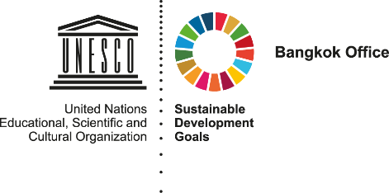

Toolkit on Strengthening Gender Equality and Social Inclusion in National Youth Policies

## **table of contents**

**Glossary**………………………………………………………………………………………………………………………………………..Page i

**Introduction**

Purpose of this Toolkit and the UNESCO Advantage……………………….…………………….…………………………Page 1

A Brief Profile of Youth Living in Southeast Asia…………………………………………….…………….………………….Page 3

Gender Equality, Social Inclusion, and Vulnerable Youth…………………………………………….…………………..Page 4

Reflection Questions: Introduction…………………………………………………………………………………………….…….Page7

**What is Youth Policy?**

What is youth policy and why are they needed?.................................................................................Page 8

Good youth policy practices and Models of youth participation……………………………………………………..Page 9

Activity: Your Policy Process………………………………………………………………………………………………………….Page 13

Reflection Questions: What is youth policy?.....................................................................................Page 15

**Policy Process**

Governance Framework………………………………………………………………………………………………………….....…Page 17

Evidence…………………………………………………………………………………………………………………………………….…Page 20

Vision…………………………………………………………………………………………………………………………………………...Page 24

Target……………………………………………………………………………………………………………………………………………Page 30

Priorities……………………………………………………………………………………………………………………………………….Page 34

Validation………………………………………………………………………………………………………………………………….….Page 41

Reflection Questions: Policy Process………………………………………………………………………….………………….Page 44

**Next Steps: Implementation**

Governance……………………………………………………………………………………………………………………………….….Page 45

Action Planning…………………………………………………………………………………………………………………….……….Page 46

Advocacy……………………………………………………………………………………………………………..……………………….Page 47

Capacity Building…………………………………………………………………………………………………..………………………Page 47

Monitoring and Evaluation………………………………………………………………………………………………………..….Page 48

**Resources and Handouts**

Resources……………………………………………………………………………………………………………….…………………….Page 50

Activity Handouts………………………………………………………………………………………………………………………….Page 53

## **Glossary**

**Adolescent:** Typically, adolescents are defined as persons who are aged 10-19 years.

**Person with Disabilities:** Persons with disabilities include those who have long-term physical, mental, intellectual or sensory impairments which in interaction with various barriers may hinder their full and effective participation in society on an equal basis with others

**Ethnic Minorities:** A group numerically inferior to the rest of the population of a State, in a non-dominant position, whose members - being nationals of the State - possess ethnic, religious or linguistic characteristics differing from those of the rest of the population and show, if only implicitly, a sense of solidarity, directed towards preserving their culture, traditions, religion or language

**Gender:** The social attributes and opportunities associated with being male and female and the relationships between women and men and girls and boys; and among women and men. These attributes, opportunities and relationships are socially constructed and are learned through socialization processes

**Gender Equality:** The equal rights, responsibilities and opportunities of those identifying by people of all genders.

**Gender Mainstreaming:** Perspectives and attention to the goal of gender equality are considered in all activities - policy development, research, advocacy/ dialogue, legislation, resource allocation, and planning, implementation and monitoring of programs and projects

**LGBTI:** Lesbian, gay, bisexual, transgender, and intersex

**Migrants:** While there is no formal legal definition of an international migrant, most experts agree that an international migrant is someone who changes his or her country of usual residence, irrespective of the reason for migration or legal status. Generally, a distinction is made between short-term or temporary migration, covering movements with a duration between three and 12 months, and long-term or permanent migration, referring to a change of country of residence for a duration of one year or more. Migrants may also be people who move internally by changing the place of usual residence to somewhere away from their original home or birthplace.

**Sex:** The biological characteristics attributed to males and females (such as testicles, ovaries, etc.)

**Social Inclusion:** The full participation of individuals or groups in social, political, and economic activities in their country.

**Vulnerable Youth:** Youth who lack the environmental, social, economic, and legal protection and safety of others, and are consistently prevented from accessing opportunities.

**Youth:** While the exact definition varies, it typically includes those who are ages 15-30. Generally, each country should use their national definition for this term.

## **introduction**

**Purpose of this Toolkit and the UNESCO Advantage**

The development and implementation of youth policies, or the strategies that governments adopt for addressing the concerns and needs of youth living in their countries, can provide great opportunities for young people coming from all backgrounds to acquire extensive leadership knowledge, while also providing them with a platform to make a difference. It is an opportunity that is often missed either due to the lack of skills and knowledge on the part of youth in the area of policy development, or the unwillingness of decision makers to engage young people.

In the two years following Ban ki-Moon’s announcement on the importance of youth in achieving the SDGs, several UN and regional agencies have actively worked towards coming up with tools and resources to help decision makers all over the world engage young people in the development of youth policies. Since 2015, several regional workshops have been held in Africa, Asia-Pacific, and the Caribbean on evidence-based youth policy development with an emphasis on M&E. This was a commitment of UNDESA coming out of the 1st Global Forum on Youth Policies, which was held at Baku, Azerbaijan in 2014 (more on this can be found on page 50 under Resources). The workshops have had a strong focus on interagency collaboration, and several UN and other agencies have been involved, including Commonwealth Secretariat and regional bodies. They have also had a strong emphasis on youth participation and working with national youth councils and youth NGOs.

In line with the work of its fellow UN agencies, as well as its own strategic commitment towards building the capacity of youth to collaborate with their country’s leaders on the development of youth-focused policies and initiatives, UNESCO developed a *Guidance Framework for Youth Policy Development.* This frameworkfocuses on the processes of formulation and revision of public policy on youth and seeks to provide a global framework that can be further adapted and contextualized to specific country settings. It also suggests a series of flexible departure points to guide national youth development planners in formulating or reviewing public policies on youth in line with the country’s priorities*.*

While the *Guidance Framework* highlights priorities and standards needed for developing and reviewing youth policy, as well as recommendations for the content of a youth policy and coordinating bodies/mechanisms, it also provides a rough roadmap of the stages that policy makers need to complete to prepare an effective policy.

In addition to these steps, the *Guidance Framework* also discusses actions that need to be taken once a policy is drafted. These include development of sectoral and multi-sectoral strategies and mechanisms, resource mobilization, and monitoring and evaluation.

Since 2016, UNESCO Bangkok has been actively building on the abovementioned *Guidance Framework.* Following this*,* as well as drawing from the *Equiframe* and *EquIPP* manuals (both published by the Centre for Global Health in Dublin, Ireland), the *Toolkit on Gender Equal and Socially Inclusive Youth Policies* provides a step-by-step guide for policymakers on how to develop inclusive, equal and participatory national youth policies. The rationale for the development of this toolkit is that more inclusive policies provide lasting social and economic benefits to the country. The steps that are outlined by the toolkit are complemented by case study examples and activities that help increase the understanding of youth policy development and implementation processes. Specifically, some of the recommendations that this toolkit provides include:

* Developing inclusive and participatory mechanisms for youth policy development;
* Gathering youth-led evidence on issues affecting young people;
* Creating a vision for a youth policy;
* Ensuring that policy priorities and objectives are not only SMART, but also gender equal and socially inclusive;
* Building consensus on youth policies through multiple consultations;

Over a period of a year and a half, this toolkit has been piloted in the Greater Mekong Sub-region. The toolkit that is being presented here is the result of these consultations, workshops, and peer review.

### **A Brief Profile of Youth Living in Southeast Asia**

Youth[1] make up a substantial proportion of the global population. It is estimated that more than 60 percent of the world’s youth live in the Asia-Pacific region alone; as of 2015, fifteen percent of global youth population were estimated to live in Southeast Asia, a sub-region consisting of eleven countries that span from Myanmar in the west to Indonesia in the east. While youth in this geographically, economically, culturally, and politically diverse region are often spoken about as one big homogenous entity, they are incredibly diverse. From the young out-of-school Muslim farmer in Mindanao, Philippines, to the Thai engineering student in Bangkok, the backgrounds and needs of youth in Southeast Asia are varied.

At the same time, however, several major challenges tie this diverse population together. First, due to various factors (such as gender inequality, ethnicity, socioeconomic status, etc.) access to quality education is often unequal. Literacy and graduation rates among the most privileged in societies continues to be much higher than those are traditionally vulnerable and marginalized. Second, as of 2018, record high secondary and tertiary education completion rates continue to be met with a lack of adequate employment opportunities. Thus, access to quality education that provides students with the skills needed for 21st century jobs is often among the top concerns for youth in the region. Second, youth are often faced with high unemployment rates and little information regarding employment opportunities. Third, health, particularly SRH (sexual and reproductive health), drug-use and prevention, and mental health, are often prioritized by young people in Southeast Asia. Fourth, the opportunity to participate in decision-making processes affecting their countries is among the top concerns of many youths in the region. Fifth, environmental sustainability in the face of overdevelopment and non-green practices is another priority. Finally, peace and security in a time where conflicts seem to arise in every corner of the world weighs heavily on the mind of Southeast Asian youth. This is especially true for those identifying as ethnic minorities. Myanmar provides a stark example of this.

With so many concerns, many youths in Southeast Asia find an outlet through youth organizations and networks. For example, to address the problems of employment, a variety of young entrepreneur associations such as Pioneer Fish in Vietnam and Young Myanmar Entrepreneurs Network have sought to train youth on how to develop new business ventures and create a more start-up friendly policy environment in their countries. These organizations are important platforms for youth, including those who are traditionally marginalized, to voice their concerns and work with other likeminded people to address them.

Despite the proliferation of youth organizations and networks, many youth in the region simply do not have the knowledge and abilities to voice their opinions, nor do they have the opportunities. While youth councils and parliaments exist in many countries, policies that affect youth are often prepared without the consultation of their target beneficiaries. When youth are involved in policy making processes, they are often the most privileged and well educated of their peers. Thus, the opportunity for traditionally marginalized young people to voice their concerns and engage with their countries’ decision makers are even more limited.

In his Five-Year Action agenda, the former United Nations Secretary General, Ban ki-Moon, announced that working with and for youth would be one of his top priorities. This was a historical move in the UN that recognized the critical importance of youth voices and leadership in working towards the seventeen United Nation’s Sustainable Development Goals (SDGs). Three years after this milestone, in the current UN Strategy on Youth (2018), “amplifying youth voices” through political participation, engagement, and advocacy is the very first of the Strategy’s five priority areas. In other words, all of ki-Moon’s original priorities, such as increasing the engagement, participation, and advocacy of youth voices, and promoting youth civic and political engagement, have continued to be emphasized.[2]

**Gender Equality, Vulnerable Youth and Social Inclusion**

In the past, programs and initiatives targeting young people often failed to grasp the diversity of their beneficiaries. When working with youth, it is first important to understand that youth in all regions of the world cannot be lumped together as one group. Effective programs must actively include *social inclusion* and *gender equality* in their development and implementation*,* so that the needs and concerns of a wider cross-section of youth do not fall to the wayside, especially those who are vulnerable.

***Gender Equality****:* The term *gender equality* cannot be understood without first understanding the differences between *gender* and *sex.* Take a piece of paper and divide it into two columns. At the top of the columns, write “gender” and “sex.” Under the column that says sex, think of all the biological characteristics of a male and female. For example, you may write “testicles” for males, and “childbirth” for females. Ask yourself: Can males give birth to children? You will hopefully answer “no.” This is a uniquely biological characteristic of females that cannot be shared. Now, under the column that says “gender,” write down some non-biological characteristics that are associated with males and females. You may write “football player” under male, or “housemaid” under females. Can males be housemaids? Certainly! Just as females can definitely be football players. While these professions are often associated with either males or females, they are not biological. Rather, they are social. An example of this activity can be found below:

|  |  |
| --- | --- |
| **Gender** | **Sex** |
| * Football player (males) * Housemaid (females) * Beautician (females) | * Testicles (males) * Childbirth (females) * Ovaries (Females) |

Hopefully, it should now be clear that “sex” refers to the biological characteristics of males and females that cannot be shared, whereas “gender” refers to the social attributes and opportunities associated with being male and female and the relationships between women and men and girls and boys, as well as the relations among women and those between men. “Gender equality” can thus be understood as the equal rights, responsibilities and opportunities of those identifying as all genders, whether it be male, female, or a third gender (see Glossary). It implies that the interests, needs and priorities of people of all genders are taken into consideration. Gender equality is a human rights principle, a precondition for sustainable, people-centered development, and it is a goal in and of itself. [3]

***Vulnerable Youth:*** As with many concepts, there is no universal definition of “vulnerable youth.” Generally, “vulnerability” means the quality or state of being exposed to the possibility of being attacked or harmed, either physically or emotionally. Through this definition, one can understand that those who are vulnerable lack protection and safety. However, it can also mean exclusion, or the denial of social and economic opportunities to an individual or group. Thus, vulnerable youth could be understood as those groups of youth who for some reason or another, lack the protection and safety of their community/society, and have consistently less access to such opportunities. To help provide a clearer picture of what type of youth are usually considered vulnerable, the table below lists some groups who the UN and other organizations have defined as vulnerable, as well as some of the challenges they may face:

|  |  |
| --- | --- |
| **Vulnerable Youth Group** | **Examples of Barriers/Challenges** |
| LGBT | Legal protection; safety; recognition |
| Youth with Disabilities | Equal access to health, education, and employment |
| Single Mothers | Legal protection; equal access to health, education and employment; safety |
| Ethnic Minorities | Legal protection; safety; recognition |
| Migrants | Legal protection; safety (at work and home) |

***Social Inclusion:*** Social inclusion can be defined in relation to “social exclusion.” According to UNESCO, social exclusion as a process and a state that derives from exclusionary relationships based on power and one that prevents individuals or groups from asserting their rights and their full participation in:

* economic life (e.g. *LGBTI youth are not hired for a job because of their sexual orientation or gender identity);*
* social life (e.g. *youth with disabilities cannot enter a building because it doesn’t have a ramp or elevator);* and
* political affairs (e.g. *ethnic minority youth do not have representation in parliament)*

Thus, social inclusion can be seen as the *full participation of individuals or groups in these areas.* The concept of social inclusion especially applies to vulnerable groups like the ones mentioned earlier.

Understanding gender equality and social inclusion is one thing; ensuring that they are in the design, development, and implementation of programs and policies is another. In order to ensure that a program or policy will be stronger and more sustainable, it is critical for program leaders and decision-makers to take the extra initiative to learn about the needs and concerns of their target populations, as well as the complexities of gender identity and how these identities are constructed. If the target beneficiary of a program is youth, then the perspectives of young people representing various genders and vulnerable sub-populations must be integrated into a program or policy process from the very beginning—from the creation of the mechanism overseeing the development of the initiative, to the implementation, and monitoring and evaluation of the initiative.

[](https://www.google.com/url?sa=i&rct=j&q=&esrc=s&source=images&cd=&ved=2ahUKEwiR-ZHU5uTdAhUS3o8KHUvJAwgQjRx6BAgBEAU&url=https://mikecavaliere.com/wtf-is-front-end-development/question/&psig=AOvVaw0QJtrauYItCecx-dmst7-h&ust=1538468139504321)**Reflection Questions: Introduction**

|  |  |
| --- | --- |
| **Question** | **Answer/Comment Space** |
| Who are the vulnerable youth living in my country? |  |
| How is gender understood in my country? |  |
| How is social inclusion understood in my country? Is it the same as this toolkit? |  |
| Are there any examples of gender or social inclusion mainstreaming in my country? If yes, what are they? |  |

## **what is youth policy?**

### **What is youth policy and why are policies needed?**

If you ever have the opportunity to work with young people, particularly those who are not typically engaged in development programs or activism, ask them this question: *what is a youth policy?* It’s highly likely that you will get many different answers that don’t exactly answer your question. The reality is that unless members of your young audience have been engaged (either actively or passively) in the development or implementation of a youth policy, they likely have never even heard of one, or they aren’t exactly certain what it is.

One of the possible reasons for this lack of understanding is that it’s difficult to come across a clear and coherent definition. When typing “what is a youth policy” or “defining youth policy” into a simple Google search, you will get hundreds of resources that try to answer these questions by either showing you how a country or region defines a youth policy, or by presenting what a youth policy should include or accomplish. If you were to ask the Council of Europe, they would tell you that “a national youth policy is a government’s commitment and practice towards ensuring good living conditions and opportunities for the young population of a country,” and that rather than being one specific document or policy, it can be a combination of several existing policies (or elements of these policies) that address youth concerns in some way or another.[4] On the other hand, many countries that have youth policies will clearly say that it’s a specific guideline that provides a framework for how various government ministries and departments will address youth. In this understanding, youth policies *are* specific strategy documents. To complicate matters further, organizations such as the UN don’t actually provide definitions, but indicators and elements of what a youth policy should include. In other words, while a Google search will provide a lot of information, you will be just as confused as when you began your inquiry, and you will surely be joined by hundreds (if not thousands) of other young curious minds.

In an attempt to simplify it, a youth policy can be understood as a country’s framework that guides how they address the concerns of young people. While countries usually develop single youth policies that cover multiple themes (e.g. health, education, etc.), there can be many types of youth policies that are specific to one theme and developed by a particular ministry or department in government, such as a youth employment policy. A youth policy can also be a framework that serves as an umbrella over many aspects of existing policies that address youth in any way.

Once you are able to convey to your group of youth what a youth policy is, it should be much easier to make them understand why it’s important to them. It’s no secret to young people that they make up a substantial proportion of the global population. The World Bank estimates that globally there are 1.8 billion young people. As shown earlier, over 60 percent of those youth live in the Asia-Pacific region.

It is also no secret to your young people what their concerns are, although they may not be aware that their particular concerns are also shared by many like them. It is true that youth are an incredibly diverse group with a wide variety of needs and concerns. However, despite their differences, there are many *broad* commonalities. As discussed earlier, for many youth, the top issues of concern are education and employment. In many of the countries in Southeast Asia, youth face high levels of unemployment. Many state that education does not prepare them or give them the skills needed to be competitive in a globalized economy. Furthermore, gender, ethnic/racial, income and other inequalities prevent various groups from accessing quality education and gainful employment. Another very common concern among Southeast Asian youth is health. Youth are often more vulnerable to the risks posed by unprotected sex and drug abuse.

These bring us back to the question of why a youth policy is important. Youth policies are important because they attempt to address many of the issues mentioned earlier. While the opinion of youth is not always given weight, most policymakers acknowledge the fact that youth make up a large percentage of the population and there is a need to ensure that this population is healthy and safe. After all, a healthy and thriving population is a healthy and thriving country.

If done well, youth policies provide young people from various backgrounds with the opportunity to engage with the policymakers and ensure that youth voices are being heard. This helps open the door to further civic participation from young people, which is greatly lacking not only in Southeast Asian countries, but all over the world. Considering their numbers, it is crucial that youth are represented in policy/civic processes.

### **Good Youth Policy Practices and Models of Youth Participation**

It is one thing to understand what a youth policy is and why it’s important; it’s another thing to develop one. Broadly speaking, policies are often developed in the following ways: 1) the policy is developed by government without the participation of youth; and 2) the policy is developed by government with the participation of youth. In the past, as with most other policies, it was common for governments to develop a youth policy without any significant consultation or involvement with youth. In August 2014, UNDP released a report entitled *Youth and Democratic Citizenship in East and Southeast Asia,* which highlighted the general attitudes felt by youth throughout the Asia Pacific towards civic engagement and participation. Despite the fact that youth are the leaders of the future and will surely be impacted by the policies made by government officials today, the report revealed that throughout the region at that time, youth had yet to become equal participants in political processes compared to older generations, and had yet to fully realize their potential role as democratic citizens.[5]

Involving youth in the development of youth policy (and any youth program, for that matter) is critical for its success. It should come as no surprise that youth have the strongest understanding of their needs and concerns. If given a platform, they will provide valuable knowledge and ideas that will strengthen a policy that is for them. This is often done with the help of youth-led organizations who often have the deepest knowledge about issues facing youth and effective solutions to address them. Furthermore, if they have knowledge about the policy, as well as ownership, they will more actively work to implement it. These ideas have been captured by various theoretical participation models, such as *Hart’s Latter of Participation.* Inthis model, youth actively working together with adults to make decisions is seen as meaningful participation, whereas consultation with youth without seriously considering their inputs (tokenism) is highly discouraged.[6]

[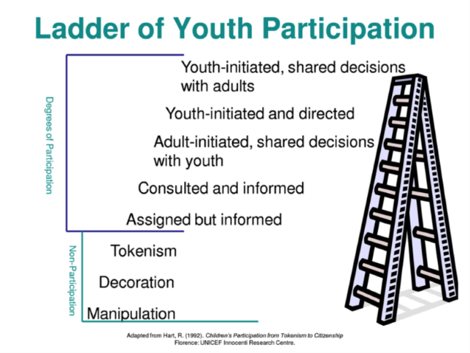](https://www.google.com/url?sa=i&rct=j&q=&esrc=s&source=images&cd=&cad=rja&uact=8&ved=2ahUKEwjIx5G7jMHcAhVNfn0KHZxICMoQjRx6BAgBEAU&url=http://www.ydep.no/maria-kristina-in-madagascar/tkraemcanhhbzgl5w7kkfwhn6fhf6c&psig=AOvVaw1neMDv5C9vWIIAwFXzr3SU&ust=1532842737150112)

**Figure 1: Hart’s Ladder of Participation**

Another example is Marc Jans and Kurt de Backer’s *Triangle of Youth Participation.* Developed in 2002, the *Triangle* model contends that young people will actively participate in society when there is a dynamic balance between the three dimensions: challenge, capacity and connection. Specifically, a challenge that incites interest from youth needs to present itself. Youth then need to feel like they have the abilities to address this challenge. Finally, youth need to feel connected with and supported by “humans, communities, ideas, range of thoughts, organizations…in order to work together” to address the challenge.[7] Additional examples of participation models can be found under Resources on page 50.

[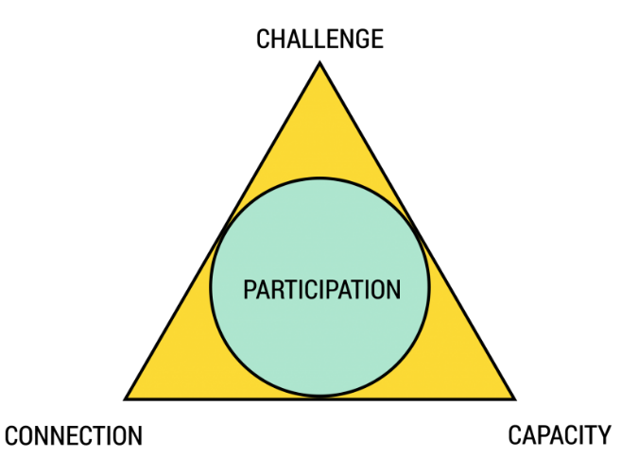](https://www.google.com/url?sa=i&rct=j&q=&esrc=s&source=images&cd=&cad=rja&uact=8&ved=2ahUKEwi4tPak2endAhXEo48KHSxSBHAQjRx6BAgBEAU&url=https://360participation.com/models-of-participation/&psig=AOvVaw1GuU5JKSKeoNQRlgq85Xz9&ust=1538636368766800)

**Figure 2: Jans and de Backer’s Triangle of Youth Participation**

Building on the participation models mentioned, and focusing strongly on the concepts of social inclusion and gender equality, UNESCO recommends that effective youth policies should be guided by the following principles:

* *Governance:* The platforms through which youth policies are developed should include young women and men, particularly those coming from marginalized and vulnerable backgrounds, and provide a space in which all government ministries and departments should work together. As noted earlier, youth-led organizations can represent the interest of many youth sub-groups in the country. The mechanisms should also be inclusive of any other relevant youth stakeholders (or those who are working on youth issues in the country).
* *Evidence:* Youth policies should be informed by mixed-method (qualitative and quantitative) data. Such evidence is not only needed to identify the needs and concerns of youth living in a country, particularly those coming from vulnerable and marginalized backgrounds, but also the legal and policy environment under which those young people live. Ideally, young people can play a central role in collecting this data.
* *Visioning:* Throughout the policy development process, it is preferable that a vision for the youth policy should be developed. As with the other recommendations, this visioning process should be inclusive and participatory of all key relevant youth stakeholders.
* *Targeting:* Effective youth policies are able to identify many youth sub-groups and examine their needs and concerns.
* *Prioritizing:* Most effective youth policies include priorities that adequately address the needs of the young people they target, as well as strong indicators that are SMART (Specific, Measurable, Attainable, Relevant, and Time-Bound).
* *Validating:* An effective youth policy is one that is validated by all of those who will lead in its implementation. Furthermore, they always include inclusive and participatory systems for monitoring and evaluating the development and implementation of the policy should be in place.

Good examples of participatory policy development include the Council of Europe’s *Youth Policy Model: How to Develop a National Youth Strategy*, the United Nation’s *Baku Commitment to Youth Policies,* and the *Youth Policy Toolbox* by the United Nations Economic Social Commission of Asia Pacific (ESCAP). More details on these publications, as well as several others, can be found on page 50 under Resources.

**Activity: Your Policy Process**

Before starting the process of developing a youth policy, it is important to understand the process of developing and implementing policies in one’s own country. The activity below provides an engaging and useful way of examining national policy processes.

[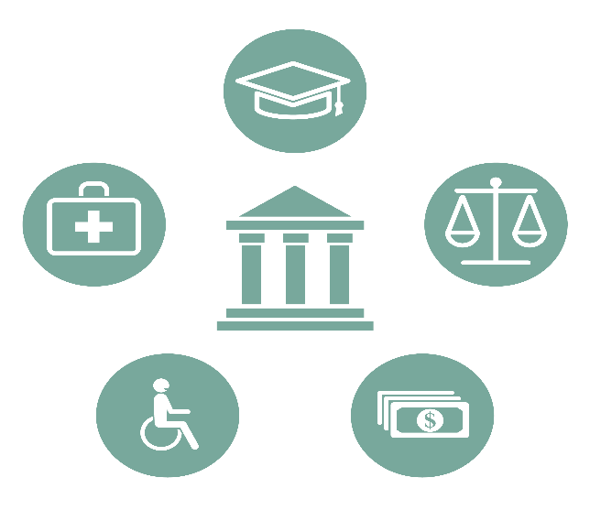](https://www.google.com/url?sa=i&rct=j&q=&esrc=s&source=images&cd=&cad=rja&uact=8&ved=2ahUKEwieteba3sbdAhVBu48KHVj8CJcQjRx6BAgBEAU&url=http://ameliequesnelvallee.org/project/policy-research/&psig=AOvVaw15xwX5D_gtV8bQcnLvPfbr&ust=1537435218877959)

**Objective:** To provide participants with the opportunity to consider the strengths and challenges of their policy processes review the policy process of your country

**Duration:**  1 week

**Materials needed (depending on preference of trainer):** Clipboard paper, markers, pens

*Activity:*

1. Create 2-3 groups of people. Ask them to create a flow-chart of the policy development process in your country. For example:

**Step 1**

**Step 2**

**Step 3**

1. After the groups have made their flow charts ask them to come together and share their findings with the other groups. Once they have shared their work, ask them to discuss the following questions:
2. What are the strengths of my country’s current policy development process?
3. What are the weaknesses of my country’s current policy development process?
4. What could be improved? How?

An example of what this could look like can be found below:

**Drafting and finalization of policy drafts through consultations with relevant government ministries**

**Drafting of Policy Priorities**

**Review of Existing Policies and Evidence Gaps**

**Creation of Inclusive and Participatory Mechanisms**

**Establishment of Steering Committee for Policy**

**Weaknesses**

**Policy Process in Country X**

**Strengths**

*What are the strengths of the process shown in the left box?*

*What are the weaknesses of the process shown in the left box (e.g. what steps and details are missing?)*

[](https://www.google.com/url?sa=i&rct=j&q=&esrc=s&source=images&cd=&ved=2ahUKEwiR-ZHU5uTdAhUS3o8KHUvJAwgQjRx6BAgBEAU&url=https://mikecavaliere.com/wtf-is-front-end-development/question/&psig=AOvVaw0QJtrauYItCecx-dmst7-h&ust=1538468139504321)**Reflection Questions: What is youth policy**

|  |  |
| --- | --- |
| **Question** | **Answer/Comment Space** |
| What policies in my country currently address the needs of youth? In what way do they address these needs? |  |
| Have the policies for addressing youth in my country been effective? Why or why not? |  |
| What are the existing platforms/spaces available for youth to talk about their issues in my country? |  |
| How participatory are my country’s policies for youth, including young women and girls and those who are vulnerable? |  |

## **POLICY PROCESS**

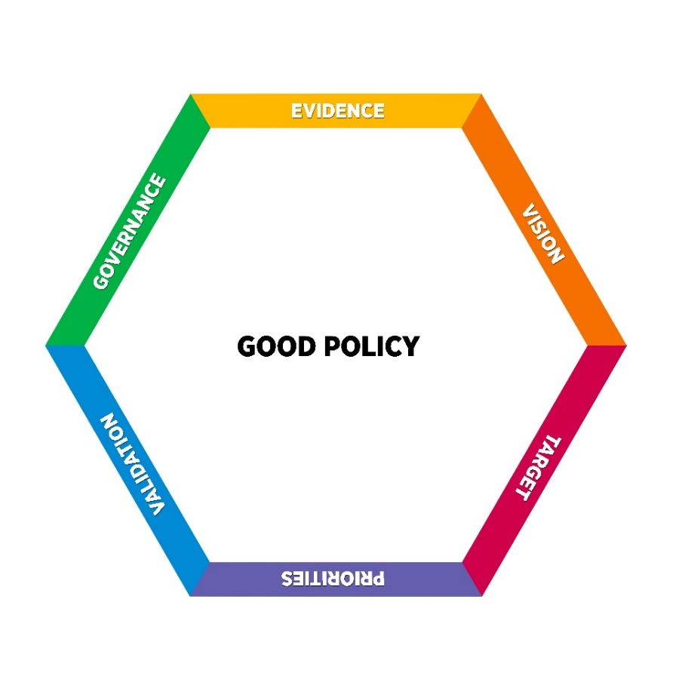First and foremost, it should be understood that there isn’t one right way to develop a youth policy. Depending on the country context, different methods and practices could be more effective than others. However, while there are many examples from all over the world, effective, participatory, and inclusive youth policies all follow a similar pattern in their design and development.

1. *Governance Framework:* Who will develop the policy? Good youth policy development begins with the establishment of inclusive and participatory mechanisms that can support the process.
2. *Evidence:* What are the issues the policy should address? Good youth policies are informed by extensive qualitative and quantitative evidence that shows the needs and concerns of youth coming from all backgrounds, as well as youth stakeholders (ministries, NGOs, etc.)
3. *Vision:* Where do we want to be at the end of the policy?A youth policy must be guided by a vision. The vision for a youth policy can change several times throughout the process.
4. *Target:* Who is the policy for? Who has specific needs? The evidence and the vision for the policy will help decide what groups are the target of the policy.
5. *Priorities:* What will the policy specifically do? The policy needs specific priorities and indicators that will be used to measure change. Without them, it is simply a wish list.
6. *Validation:* Finally, who needs to endorse the policy? After all the work has been done, a good policy needs to be validated by all of those who will lead in its implementation, including its target beneficiaries.

### cid:FD28D003-BCA1-4929-917D-A9729999537D@SSG-140**Governance Framework**

**Recommended Actions:**

* Conduct initial consultations with key stakeholders who will be

involved in the process

* Establish an exploratory committee (and later a Steering Committee)
* Conduct a Stakeholder Analysis
* Establish Inclusive and Participatory Mechanisms for

Analysis/Policy Development that are inclusive of youth, and set up interdepartmental task forces and intergovernmental committees within those mechanisms

It should be fairly straightforward that all policies, projects, and initiatives require some form of management and development framework in place before the work is started. However, what’s less straightforward is how such frameworks should be set up, and who should be involved in them. Good youth policies that are participatory, socially inclusive, and gender equal have in place systems that ensure that persons who will be potentially affected by the policy, including vulnerable and marginalized youth, are represented.

**Conduct initial consultations with key stakeholders who will be involved in the process:** Interest from key stakeholders and authorities, as well as their opinions and feedback, must be secured in order to develop a policy.

### **Questions to consider**

* Who are the relevant stakeholders?
* What is their knowledge/experience with youth development issues and policy processes? What is their level of interest in youth development?
* What kind of influence do the stakeholders have?
* Do the stakeholders represent young women and other vulnerable groups?
* Are there opportunities for youth to be involved?

**Conduct a Stakeholder Analysis:** Examine who the relevant stakeholders are in relation to youth policy and youth development and analyze their interest, policy positions, knowledge of youth development, occupation and etc. This can be conducted by the exploratory committee mentioned under the Governance Framework section.

**Establish an exploratory committee:** An exploratory committee consisting of key stakeholders and authorities (Ministries, UN, youth, CSOs) can be set up to explore the policy development process. It should include a broad range of stakeholders representing many interests and groups if possible. At the very least, it should have a gender balance.

**Recommended Components of Policy Mechanisms**

*Steering Committee:* This is the highest group at policy level. It identifies the mandate of the process and validates the outcomes in the different stages as well as the final recommendations. This group generally comprises representatives of each of the principal stakeholder organizations: the government, the legislative bodies, and national organizations or groups –including youth groups.

*Advisory Committee:* This is the highest mechanism at the intellectual level. It includes academics and opinion leaders in the country and sometimes the region. Advising on substantive content, the committee in general supports the development of the policy development process*.*

*Technical Working Committee:* This group is responsible for guiding preparation on a day-to-day basis. It brings together representatives of the main stakeholder organizations (including youth organizations) that are involved in the policy development process.

*Youth Advisory Committee:* Some countries establish a separate consultative committee consisting only of youth. This committee is responsible for advising on the writing and development of the policy, as well as gathering the evidence that informs it.

**Establish inclusive and participatory mechanisms for analysis/policy development:** Considering relevant stakeholders, including youth representatives from various backgrounds, establish inclusive and participatory mechanism for situational and contextual analyses, policy analysis, and policy development. This mechanism should include several of the components highlighted in the box on the right, such as a steering committee or youth advisory committee. Tokenism of youth must be avoided at all costs. Instead, giving youth an active decision-making role within the mechanism is preferable.

### Case Study: Participatory Youth Policy Mechanisms in myanmar

The mechanism established by the government of Myanmar for the development of its national youth policy included up to 40 youth representatives to take part in the process. In the “policy drafting committee”, there were twenty-eight youth (two from each State). Within this particular committee, specific seats were allocated to youth representatives of the LGBTI, disabled, and women’s communities. In the technical working committee, there was one representative from each state (total 14). There were also two representatives per state in the steering committee. The Assistant Director from the Ministry of Social Welfare and Youth/Child Department acted as the secretary in all of the committees.

**Central Committee**

**Technical Working Committee**

**Policy Drafting Committee**

### **Questions to consider**

* Do the committee members represent groups affected by the youth policies/development process?
* Are the committees accessible to those who are traditionally excluded?
* Do the committees provide opportunities for youth involved to engage both in consultative and leading roles?
* Do the committees encourage the participation of young women?

**Set up interdepartmental task forces and intergovernmental committees within mechanism/platform:** Coordination and sharing of priorities/plans across relevant government sectors and levels is imperative to the design and delivery of a joined-up strategy tailored to local needs. An interdepartmental task force and intergovernmental committee can be set up within the participatory mechanisms. This can be incorporated within the other committee structures if desired.

[](https://www.google.com/url?sa=i&rct=j&q=&esrc=s&source=images&cd=&cad=rja&uact=8&ved=2ahUKEwj2_OHCkOfdAhUYeysKHVQ7CLwQjRx6BAgBEAU&url=https://thenounproject.com/term/checklist/5166/&psig=AOvVaw3t2Spozzls7qGbeYPe_t0x&ust=1538548114819552)

**Checklist: Governance Framework**

|  |  |  |
| --- | --- | --- |
| Item | Yes | No |
| Exploratory committee is established |  |  |
| Stakeholder analysis conducted |  |  |
| Stakeholder analysis is inclusive of youth |  |  |
| Participatory mechanisms (consisting of a steering committee, advisory committee, youth advisory committee, and a technical working group) are established |  |  |
| Interdepartmental/interministerial task force established within mechanism |  |  |
| Mechanisms are socially inclusive |  |  |
| Mechanisms are gender equal |  |  |

### cid:FD28D003-BCA1-4929-917D-A9729999537D@SSG-140**Evidence**

**Recommended Actions:**

* Conduct a desk review of existing evidence and identify the current evidence gaps
* Collect data based on evidence gaps
* Share existing data
* Review and analyze existing youth policies and/or related policy

development processes

For a policy to accurately address the needs and concerns of its target beneficiaries, it must be informed by evidence. This evidence should try to paint the most accurate picture of youth possible, so it is crucial to look at sub-populations, such as those who are traditionally marginalized and “voiceless.” It is important to review/collect both qualitative and quantitative sex disaggregated evidence to understand both who is affected, how they are affected.

### Youth-Led Research: The case of Vietnam

[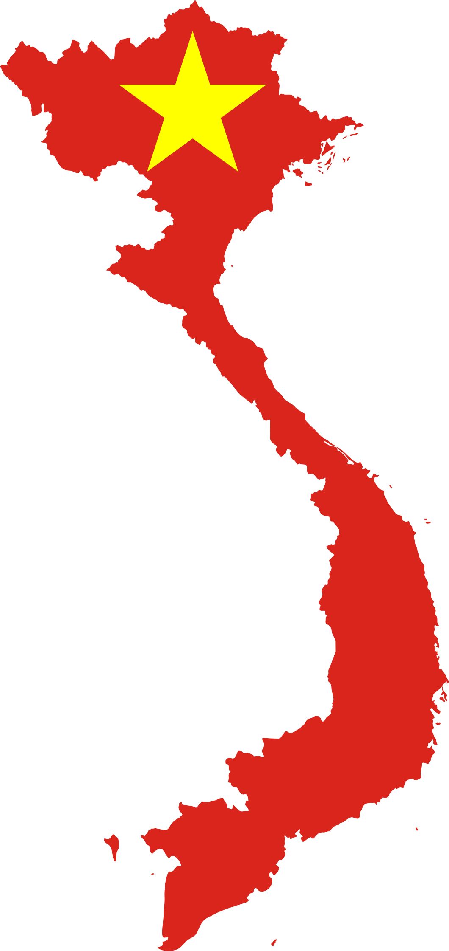](https://www.google.com/url?sa=i&rct=j&q=&esrc=s&source=images&cd=&ved=2ahUKEwjBvPP57cHdAhWKto8KHQ08CW8QjRx6BAgBEAU&url=https://openclipart.org/detail/273354/vietnam-map-flag&psig=AOvVaw1C2c8RptZ2UgqZobtIB2CN&ust=1537267528978242)

In 2018, UNESCO, in collaboration with UNESCO Chair Penn State University (PSU) and National University Ireland Galway (NUI), trained 22 youth from across Vietnam to collect qualitative and quantitative data on the issues facing vulnerable youth, particularly LGBT, disabled, ethnic minority, student, and sex worker youth. The two-day training was held in Hanoi and specifically focused on building skills in conducting interviews, research ethics, appropriate research methodologies, and formulating research questions. The content used in the training was adapted from UNESCO Chair’s NUI’s *Youth as Researchers* training manual. With support from the Ministry of Home Affairs of Vietnam, the research will contribute to the revision of Vietnam’s current National Youth Law, which was passed in 2005.

**Conduct a desk review and identify the current evidence gaps:** Prior to any new data collection efforts, it is important to do a desk review (also known as a literature review) on the current information available on youth living in your country. This will help you to identify what information is missing and what needs to be added.



**Collect data based on these gaps:** Following the desk review, a combination of quantitative and qualitative data collection methods should be used in order to find any information on youth that is missing in your country. Design and implementation of this data collection and analysis should be led by a group that understands the needs of youth, including those who are vulnerable and marginalized. An example of youth-led research can be found on the right.

[](https://www.google.com/url?sa=i&rct=j&q=&esrc=s&source=images&cd=&cad=rja&uact=8&ved=2ahUKEwiThOLolufdAhUOTI8KHcvqAc0QjRx6BAgBEAU&url=https://ubisafe.org/explore/collocution-clipart-data-scientist/&psig=AOvVaw1Le57w6nPyn6JMNlHF_h91&ust=1538549799377261)

**Share Existing Data:** Data should be shared among the various government ministries, as well as universities and NGOs. Lack of integration of civil registration and administrative data not only hinders the effective collaboration between government departments but also imperils evidence-based decision making and results-based management in general. Such sharing can occur within the intergovernmental/inter-sectoral committees

**Review and analyze existing youth policies and/or relevant policies:** Existing youth policies and/or relevant policies should be analyzed to determine their effectiveness and linkages.

Further suggestions to consider when reviewing the policy development process:

1. The policy is designed and implemented within a human rights based framework and in line with the country’s global and regional commitments on youth and the Sustainable Development Goals (SDGs);
2. The policy promotes and enables gender equality; and
3. The policy enables and promotes inclusive youth civic engagement and forsees, at all stages, inclusive processes for youth participation, including in terms of strengthening related capacities of youth organizations and ensuring the representation of the national youth bodies.

### **Questions to consider**

* What data on youth currently exists? Who collected it? When was it collected and where?
* What are the gaps in the current data on youth?
* Does this data include information on vulnerable youth groups, such as women, LGBT, disabled, ethnic minority, etc.?
* What is the opinion of youth from various backgrounds on the situation in their countries?
* Is the data qualitative and quantitative?
* What resources are available for data collection and analysis?
* What youth groups do current policies focus on?
* What evidence are they informed by? What are the gaps?
* Are specific vulnerable youth sub-groups mentioned in the policy?
* Who was involved in the development of the youth policy? What is/was their role?
* Is the policy gender equal?
* How accurately does a country’s youth policy reflect the priorities of youth?
* How successful was the policy’s implementation? Who was involved in its implementation?
* What system for monitoring and evaluation of the policy was in place? Who was involved with this? Was it successful?

**Youth-Led Research Proposal Template/Example**

In 2018, young people living in Laos were trained on how to collect mixed-method data on vulnerable youth. The purpose of this data collection was to provide evidence for the development of Laos’ first ever national youth policy. This particular proposal focused on youth who were addicted to methamphetamines and living in Savannakhet, the second most populous province in Laos.

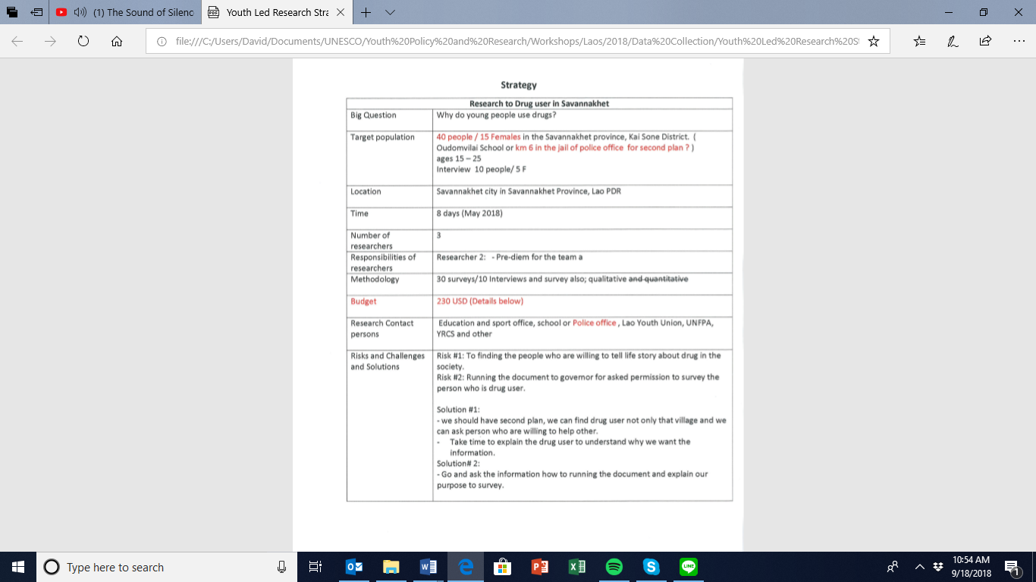

[](https://www.google.com/url?sa=i&rct=j&q=&esrc=s&source=images&cd=&cad=rja&uact=8&ved=2ahUKEwj2_OHCkOfdAhUYeysKHVQ7CLwQjRx6BAgBEAU&url=https://thenounproject.com/term/checklist/5166/&psig=AOvVaw3t2Spozzls7qGbeYPe_t0x&ust=1538548114819552)**Checklist: Evidence**

|  |  |  |
| --- | --- | --- |
| Item | Yes | No |
| Desk review of existing data on youth in my country has been conducted |  |  |
| Gaps in existing data on youth in my country have been identified |  |  |
| Existing data on youth has been shared among government ministries/departments, UN agencies and NGOs in my country |  |  |
| Resources for collecting new quantitative and qualitative information on youth in my country, particularly those who are vulnerable, are available |  |  |
| An inclusive mechanism for collecting and analyzing new information on youth in my country has been established |  |  |
| The capacity and skills of members of this mechanism to collect and coordinate data collection efforts, particularly on vulnerable youth, have been developed |  |  |
| The gaps and successes of existing policies relating to youth have been examined and analyzed |  |  |

### cid:FD28D003-BCA1-4929-917D-A9729999537D@SSG-140**Vision**

**Recommended Actions:**

* Build the skills and understanding of all persons involved

in the development of the policy on how to create a policy vision

* In consultation with relevant stakeholders,

determine the purpose and goal of the youth policy

* Set a timeframe for the policy

A vision is what one wants for the future. All policies, whether they are specifically targeted at youth or not, should be guided by some sort of vision, or an overall goal. Most importantly, these visions should be inclusive. While it is good to have an idea of what the vision for the policy should be very early on in the process, it can be better informed if it follows the collection and analysis of data on the issues that youth face. A good vision is one that addresses the needs of everyone covered by the policy, including those who are disadvantaged.

**Build the skills and understanding of all persons involved in the development of the policy on how to create a vision:** Visioning is not as easy as it sounds, and it’s likely that many of the persons involved in the youth policy process may not know where to start, or how to articulate their aspirations for the policy. It is thus important to provide some sort of training on policy visioning and ensure that stakeholders have a firm understanding of what they want the policy to achieve.

### **Questions to consider**

* What are the visions of other policies relating to youth?
* Does the existing youth policy have a clear vision that is inclusive and promotes gender equality?
* What is the capacity of persons involved in the development of the youth policy to come up with a vision for a policy, especially youth?
* What challenges are currently preventing the creation of a clear and inclusive vision?
* Is the vision for the youth policy realistic (can it be achieved)?
* Who is the vision for? Does the vision reflect what youth want?
* What is the time frame of the policy? Can its goals be achieved in this period?



**In consultation with relevant stakeholders, determine the purpose and goal of the youth policy:** It is important for the persons involved in the development of the policy to work together to come up with a vision that is inclusive, realistic, and effective. While this work can begin during the early stages of development, it is important to reaffirm the vision and ensure that it remains consistent with the policy content throughout the entire process.

### creating a youth-policy vision by imagining the future:

### The case of Laos

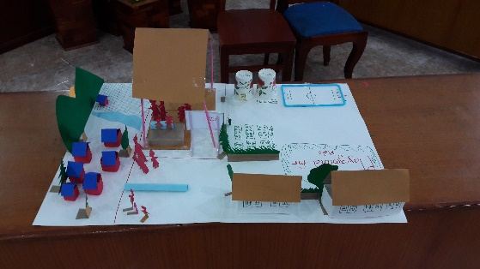 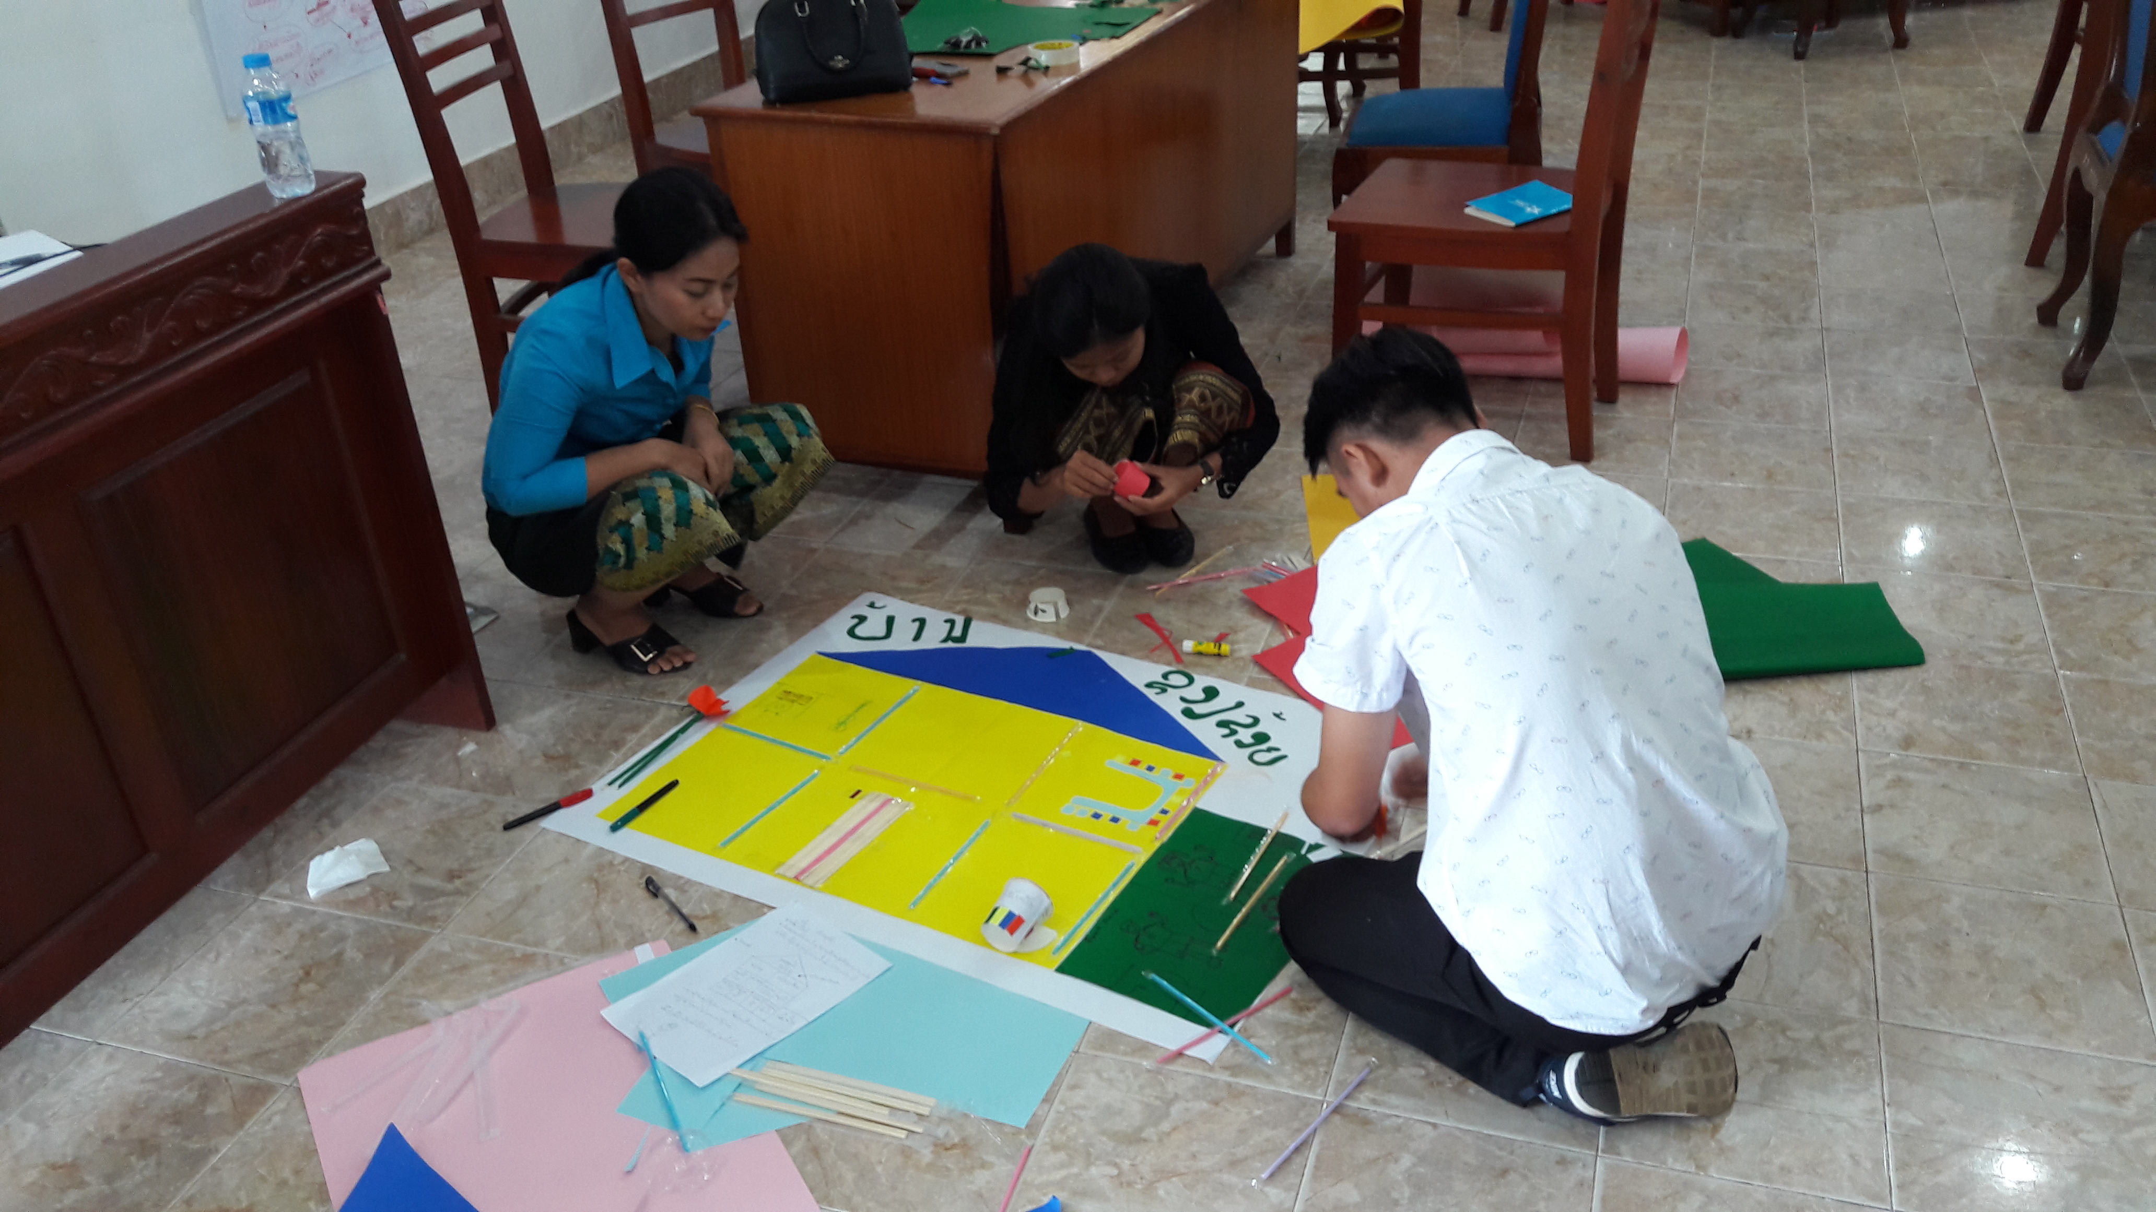

In 2018, UNESCO provided support to the Lao People’s Revolutionary Youth Union (LYU) to help young people and LYU members create a vision for the country’s draft national youth policy. Specifically, UNESCO organized a two-day training in which an expert on “futures literacy,” a discipline in which the future is imagined in order to come up with solutions for today, taught the participants how to come up with a vision for each of the draft’s five themes (education, employment, health, participation, and protection). Participants were asked to imagine the default future (the future based on current realities), as well as to come up with solutions for current issues. At the end of the training, after creating visual models of their preferred future as it related to one of the earlier mentioned themes (as seen in the photos above), the participants were asked to articulate their vision in writing. A detailed guide on how to do this activity can be found on the next page.

[](https://www.google.com/url?sa=i&rct=j&q=&esrc=s&source=images&cd=&cad=rja&uact=8&ved=2ahUKEwighLaYoOfdAhVKu48KHZVXBbsQjRx6BAgBEAU&url=http://www.cerealto.com/who-we-are/vision-mission-and-values/&psig=AOvVaw19pI4VfWMjRXEengxAVGT1&ust=1538552321267855)

**Set a time-frame:** When developing a youth policy, it’s important that a clear time-frame be established. Sometimes, countries create youth policies to match with their national development strategies. It is recommended that a youth policy’s time-frame be no more than 10 years.

**Activity: Creating a Youth-Policy Vision by Imagining the Future**

The activity below is based on a training provided by the Centre for Engaged Foresight for youth and policymakers in Laos that was sponsored by UNESCO and the Lao People’s Revolutionary Youth Union (LYU). The Centre for Engaged Foresight is an organization in the Philippines that promotes the discipline of “futures literacy.”

**Objective:** To create a vision for a youth policy.

**Duration:** 2 days.

**Materials needed (depending on preference of trainer):** Clipboard paper, cardboard, colored construction paper, popsicle sticks, tape, straws, scissors, glue sticks

[](https://www.google.com/url?sa=i&rct=j&q=&esrc=s&source=images&cd=&cad=rja&uact=8&ved=&url=https://www.tdworld.com/smart-grid/planting-seeds-future-grid&psig=AOvVaw2xUGNbLJXlxuiwdEdzbffa&ust=1537336043704642)

Part 1: The Current Reality of Youth and its Causes (Estimated Time: 45-60 minutes)

* Divide people into groups based on the themes of the youth policy draft. Tell them that they will stay in these groups throughout the entire activity.
* Ask them to discuss and write down the answers to the following questions. Each group will do their work in this context: 1) What is the status quo of youth in their country? 2) What are the challenges of youth in their country? 3) What are the needs of youth in their country?
* On clipboard paper, ask them to present their answers to other groups
* After the groups are finished presenting, ask them to discuss the causes of the realities that they have identified and recorded these. Once they have finished doing this, ask them to again present to the others.

Part 2: The Futures Wheel Analysis, or the “Default Future” (Estimated Time: 2 hours)

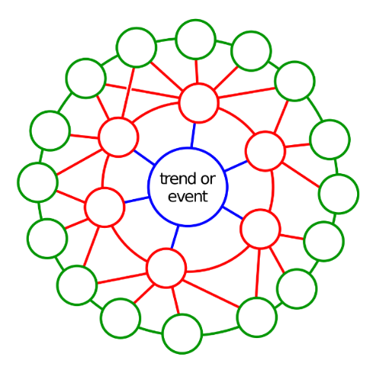

* In the same groups, ask them the participants to discuss the following question: 1) What are the impacts/implications of the current reality, the challenges, trends be if it continues to exist in the next 20-30 years?
* Using the “futures wheel” (see right), ask them to map out the impacts/implications of the current realities.
* Ask the groups to present their answers.

Part 3: How Might We…? (Estimated Time: 1 hour)

* Ask the participants to rephrase the problems that they identified as “how might we questions.” By turning the problems into questions, participants could think of a way to provide answers in the form of solutions

**Possible Solution #1**

Raise awareness to communities of the importance of education for both males and females

**How Might We…?**

How might we provide young men and women living in rural areas with equal access to education?

**Problem/Current Reality**

Young men and women living in rural areas do not receive equal access to primary and secondary education

Part 4: The Futures Triangle (Estimated Time: 1-2 Hours)

[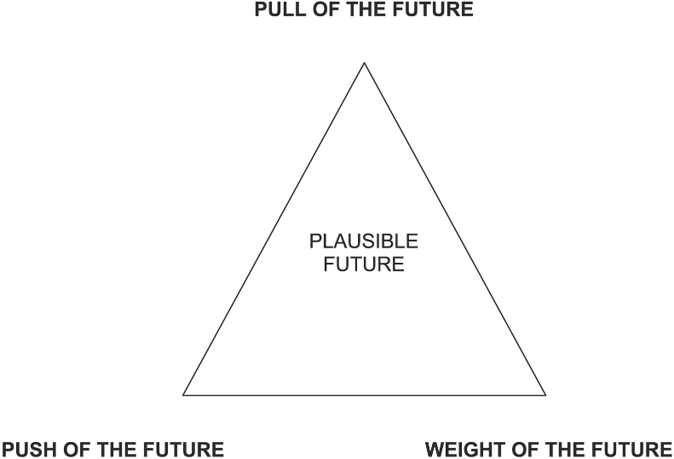](https://www.google.com/url?sa=i&rct=j&q=&esrc=s&source=images&cd=&cad=rja&uact=8&ved=2ahUKEwiQuOepsNzbAhWHTn0KHUSNC-YQjRx6BAgBEAU&url=https://chrisriedy.me/the-futures-triangle-7ef2ed728a02&psig=AOvVaw1W9Bx8SBZJd_M2_QKpk-iH&ust=1529382606862757)

* Having thought about the “default future” and ways in which to challenge the future, ask the groups to create a “futures triangle.” The futures triangle consists of three concepts (pull, weight, and push). The “pull” is the aspiration for the future. It is the goal. The “weight” is what is preventing this aspiration from being realized. The “push” is how one can overcome the challenges of the weight and move towards the pull.

Part 5: Building a Model for the Preferred Future (Estimated Time: 2-4 Hours)

* Based on the “futures triangles” that they developed, ask the groups to build models that represent the vision they came up with. In other words, they will build a model that will show “the pull” of the triangle, as well as some of the solutions that they came up with during the previous parts (see Parts 2 and 3). The participants will need the materials suggested earlier to build these models. Allow them a lot of time to complete these.
* Once the groups have completed their models, ask them to present. Below are some examples of the models developed in Laos in 2018.

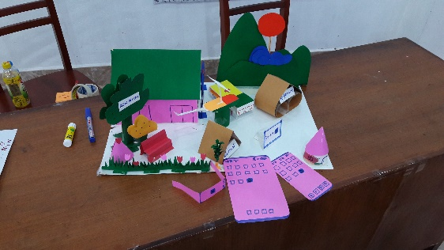 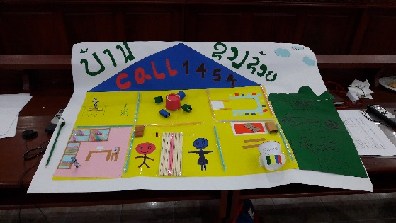

Above: Health theme Above: Protection theme

 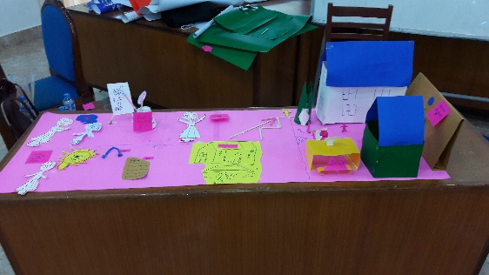

Above: Participation theme Above: Employment theme

Part 6: Articulating a Vision for Youth Policy (Estimated Time: 1-2 Hours)

* The final activity that the groups will be asked to do is write down what their youth policy vision is. This will be based on the models they have developed. After they have presented their models, provide the groups with a handout. This can be found on page ……….

[](https://www.google.com/url?sa=i&rct=j&q=&esrc=s&source=images&cd=&cad=rja&uact=8&ved=2ahUKEwj2_OHCkOfdAhUYeysKHVQ7CLwQjRx6BAgBEAU&url=https://thenounproject.com/term/checklist/5166/&psig=AOvVaw3t2Spozzls7qGbeYPe_t0x&ust=1538548114819552)**Checklist: Vision**

|  |  |  |
| --- | --- | --- |
| Item | Yes | No |
| Stakeholders have the skills needed to develop a vision for a youth policy. |  |  |
| An inclusive and realistic vision that was developed with the participation of youth, including those who are vulnerable, has been established |  |  |
| A realistic timeframe for the policy has been determined. |  |  |

### cid:FD28D003-BCA1-4929-917D-A9729999537D@SSG-140**Target**

**Recommended Actions:**

* Defining key terms
* Create an accurate profile of youth and their priorities
* Re-examine policy vision
* Re-examine evidence needs
* Consider the specific needs of young women and girls

Once the evidence and the vision for the policy are available, its target beneficiaries need to be identified. The map of youth living in a country and their needs and concerns must be an exhaustive one that is socially inclusive and gender equal. When creating an accurate profile of youth and their priorities, as many youth sub-populations as possible must be considered.

**Defining Key Terms:** Considering local and international contexts, key terms such as gender, equality, social inclusion, and many others should be defined. Understanding the international and local meanings of these terms will be needed to continue in the policy development process. Some of the definition used in this toolkit are covered in the Glossary section, found on page…



[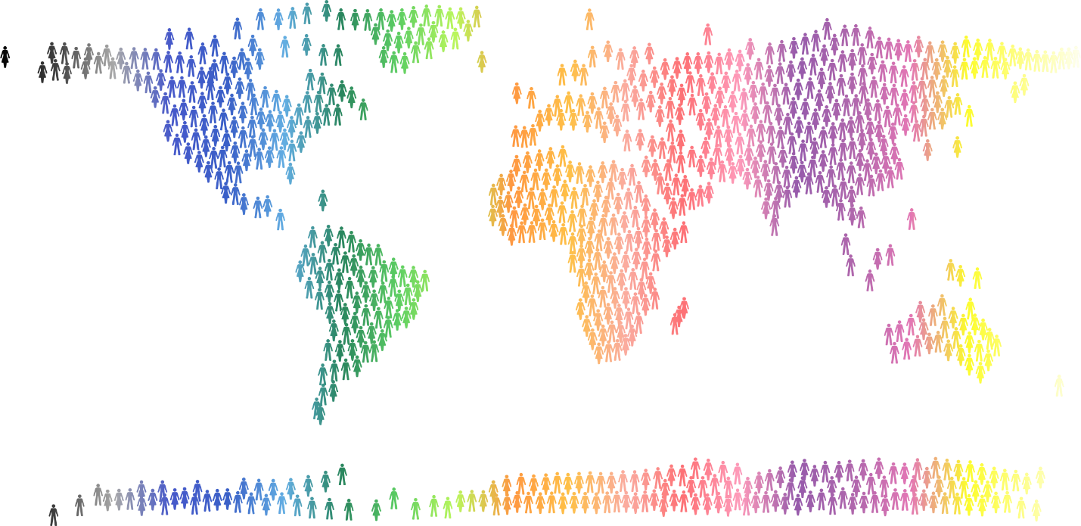](https://www.google.com/url?sa=i&rct=j&q=&esrc=s&source=images&cd=&cad=rja&uact=8&ved=2ahUKEwidxaHWicTdAhXEsI8KHSxUAU4QjRx6BAgBEAU&url=https://openclipart.org/detail/277374/people-world-map-prismatic-4&psig=AOvVaw3CEkF2pHJuNGAmZHennJGr&ust=1537343685873050)

**Creating an accurate profile of youth and their priorities:** In identifying the target youth groups, 4 key questions need to be asked:

1. Who are the youth?
2. Where are the youth?
3. What are the youth doing?
4. What are the priorities of the youth?
5. Which sub-populations are most vulnerable?

### **Questions to consider**

* Who are the youth living in your country? Where are they living? What are their needs and concerns? Consider youth from various backgrounds and gender identities.
* What groups of youth have traditionally lacked protections and suffered from social exclusion?
* What are the causes of the problems faced by youth from various backgrounds? How are these problems being addressed, if at all?
* In what areas/spheres do youth have a lot of influence (if any)?
* What is the power dynamic/relationship between youth and policy makers in your country? In other words, are youth listened to? If yes, at what level?
* What are the main factors of socialization in young people’s lives in your country? In other words, how are identities constructed in your country?
* What is the opinion of youth from various genders on the situation in their countries/policy?
* What are the power dynamics among varying genders? For example, what is the power dynamic between men and women by birth?
* Are there barriers for the participation of young women and girls? What are they?
* What are the aspirations of people of different genders?
* How well does the vision match with the priorities of the youth identified? Does it need to be adjusted?
* Where is there a lack of evidence? Which youth groups need more information?

**Re-examine policy vision and evidence:** After a thorough mapping of youth sub-populations and their priorities, it is important to go back to the vision created in the earlier section and see how well it matches with their priorities. Visioning should not be seen as a one-time step/action, but as something that should be re-examined and re-evaluated throughout much of the policy development process.

The same logic applies for evidence. During the mapping of youth sub-populations and their priorities, it may be discovered that there is still a lack of evidence for these particular groups. Wherever there are gaps, efforts should be made to try and fill them.

[](https://www.google.com/url?sa=i&rct=j&q=&esrc=s&source=images&cd=&cad=rja&uact=8&ved=2ahUKEwjWjOfVpefdAhUBYo8KHSbFB0wQjRx6BAgBEAU&url=https://en.wikipedia.org/wiki/Female&psig=AOvVaw0zoQWh1Sq4GTs453xhinuF&ust=1538553791770464)

**Consider the specific needs of young women and girls:** Understanding the needs of young women and girls and how they can be addressed is critical for the success of a youth policy. Thus, when creating a profile of the youth in a country, special attention should be paid to this particular sub-group.

**Activity: Who Are the Youth?**

The activity below allows everyone to map youth (including vulnerable youth sub-populations) living in their country/region, and the priorities of those youth. It is an activity that has been done by UNESCO at several workshops focused on youth.

[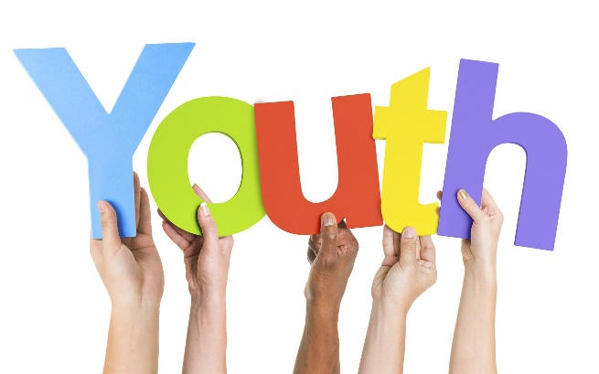](https://www.google.com/url?sa=i&rct=j&q=&esrc=s&source=images&cd=&cad=rja&uact=8&ved=2ahUKEwi-1uqri8TdAhXJPo8KHY-OBqwQjRx6BAgBEAU&url=https://batemancatholic.org/year-of-youth-launch-mass-3rd-december-2017/&psig=AOvVaw1SoLI6Lp7qLvrhA9YXpo-d&ust=1537344135114941)

**Objective:** To create an inclusive profile of youth in a country/region.

**Duration:** 1-2 hours

**Materials needed (depending on preference of trainer):** Clipboard paper, markers, pens

1. Divide the participants of the activity into several groups. It’s recommended that each group have 5-8 people at most.
2. Ask each group to think about the youth sub-populations living in their country and write them on a piece of clipboard paper. Remind them to think about young women, disadvantaged and vulnerable youth sub-populations.
3. Once the groups have finished their work, ask them to present to the other groups. This will help them think about some of the youth sub-populations they may have missed.
4. After all of the groups have finished presenting, ask them to consider the concerns and priorities of the youth sub-populations they have identified. Once they have completed, they can present these to the other groups.

[](https://www.google.com/url?sa=i&rct=j&q=&esrc=s&source=images&cd=&cad=rja&uact=8&ved=2ahUKEwj2_OHCkOfdAhUYeysKHVQ7CLwQjRx6BAgBEAU&url=https://thenounproject.com/term/checklist/5166/&psig=AOvVaw3t2Spozzls7qGbeYPe_t0x&ust=1538548114819552)**Checklist: Target**

|  |  |  |
| --- | --- | --- |
| Item | Yes | No |
| Local and international terms such as gender equality, social inclusion, etc. have been defined and understood by stakeholders |  |  |
| The needs and concerns of youth sub-groups living in my country, including those who are vulnerable, have been mapped out and thoroughly examined |  |  |
| The policy vision created under the “Vision” stage has been reexamined and revised to suit the needs and concerns of the youth sub-groups mapped during the “Target” stage |  |  |
| The specific needs and concerns of young women and girls in my country have been included in the map of youth sub-groups |  |  |
| The policy vision created and reexamined addresses the needs and concerns of young women and girls living in my country |  |  |

### cid:FD28D003-BCA1-4929-917D-A9729999537D@SSG-140**Priorities**

**Recommended Actions:**

* Set clear objectives of policy going forward and establish clear responsibilities
* Elaboration of key priorities for future policy
* Develop specific strategies for addressing these priorities
* Select appropriate indicators that will be used for measuring change
* Ensure that priorities and objectives are SMART

At this stage in the policy development process, it is time to come up with specific objectives for addressing the needs and concerns of youth identified by the evidence, and to ensure that those objectives are in line with the vision that has been established. It is important to also remember that the development of clear priorities must be inclusive and participatory of the persons whom they are targeting.

### **Questions to consider**

* What are the goals of the proposed policy?
* Do these goals address the problems?
* What change do you wish to achieve with this proposed policy?
* What are the key priorities and aspirations of youth in x country? How do they relate to gender and social inclusion?
* How do priorities differ among different youth groups in x country? What are the proposed actions for addressing these priorities?
* Do the objectives address the roots of the problem, or only its symptoms?
* How will new actions and objectives contribute to youth development, inclusion, and participation?
* How will the new actions promote gender equality and ensure that exclusion of gender is reduced or eliminated?
* How will the new actions promote social inclusion and ensure that exclusion is reduced or eliminated?
* What new or revised tools are needed for strengthening and ensuring gender equality and social inclusion in youth activities?
* Are specific priorities needed for young women?

**Set clear objectives of policy going forward and establish clear responsibilities:** It’s important to identify clear objectives for a future policy, and to also assign one lead agency with clear responsibilities for each policy area/theme.

**Elaboration of key priorities for future policy:** At this point in the process, priority areas for making youth policies more socially and gender inclusive should have been identified. Nonetheless, it is important to take time to elaborate what the priorities are and build a consensus among all who are involved in the development process, including relevant stakeholders active in the participatory mechanisms. Once a consensus is reached on the goals and priorities, an analysis of the priorities and how they will be measured needs to be conducted.

**Separate of Integrated Action Plan?**

Some policies outline a series of objectives at the strategic level and use a separate action plan to elaborate how the policy will be implemented. Others take a more detailed approach, integrating strategic direction and action. It will depend on the processes already established in each country as to which model should be followed.

**Developing Strategies for Addressing these Priorities:** In consultation with all relevant stakeholders and affected persons, specific strategies for addressing the priority areas of the policy must be developed. They must be clear and agreed upon by all concerned persons in the policy development process. The policy should not be too ambitious, but lay out a plan for what would be achieved within its timeframe. This may mean not all issues are addressed.

[](https://www.google.com/url?sa=i&rct=j&q=&esrc=s&source=images&cd=&cad=rja&uact=8&ved=2ahUKEwijzKba1ZveAhUKtI8KHZseD1YQjRx6BAgBEAU&url=http://www.vipinkhandelwal.com/5-key-qualities-of-smart-people/&psig=AOvVaw3VFTgRKj5fyZMmuLwpwXrX&ust=1540353314554365)

**S***pecific*: Who is the priority for?

**M***easurable*: Can it be quantified?

**A***ttainable:* Can it be accomplished within a certain time-frame?

**R***elevant*: Does it match the vision of the policy and the needs of its intended beneficiaries?

**T***ime-bound:* When will it be achieved by?

**Ensure that priorities and objectives are SMART:** The priorities that are chosen must be Specific, Measurable Attainable, Relevant and Time-Bound (SMART). Additionally, they should be socially inclusive and gender equal.

### **Questions to consider**

* Who will be involved in the process of setting targets? Is the process of selection inclusive and participatory?
* How will change be measured, monitored, and evaluated?
* Which priorities and objectives are most likely to address the identified problems effectively and best contribute to achieving the desired objectives and outcomes?
* How will each priority and objective affect the target population?
* How does each priority and objective meet human rights standards?
* What resources will be needed to implement each of the priorities and objectives?
* What are the threats associated with the priorities and objectives being considered, including the threat of unintended and undesired consequences, and how might these risks be managed?
* Based on the resources available, how many of the priorities can be realistically achieved in the time-frame of the policy?

**Select Appropriate Indicators that will be used for measuring change** Once the priorities have been elaborated and objectives identified, it’s important to discuss what indicators will be used to measure the change desired by the policy.

[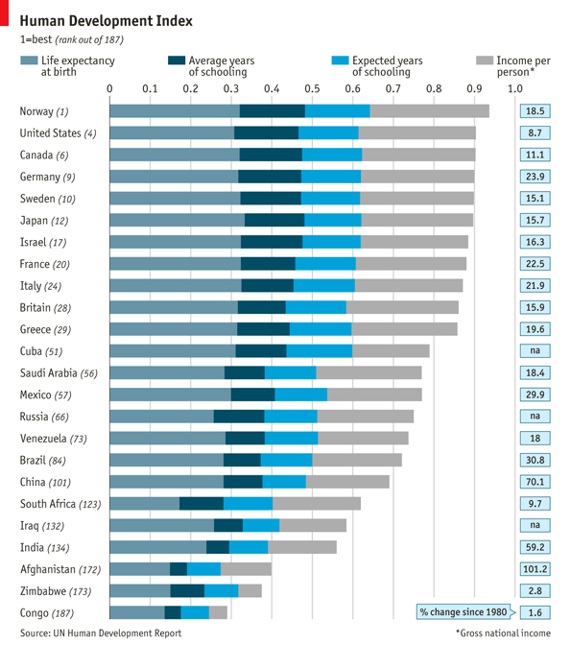](https://www.google.com/url?sa=i&rct=j&q=&esrc=s&source=images&cd=&cad=rja&uact=8&ved=2ahUKEwi2tsjF3ZveAhVBWX0KHcO8BjYQjRx6BAgBEAU&url=https://www.economist.com/graphic-detail/2014/07/15/deconstructing-development&psig=AOvVaw0SJid6l4IqJDvPFQndWwt_&ust=1540355486628119)

[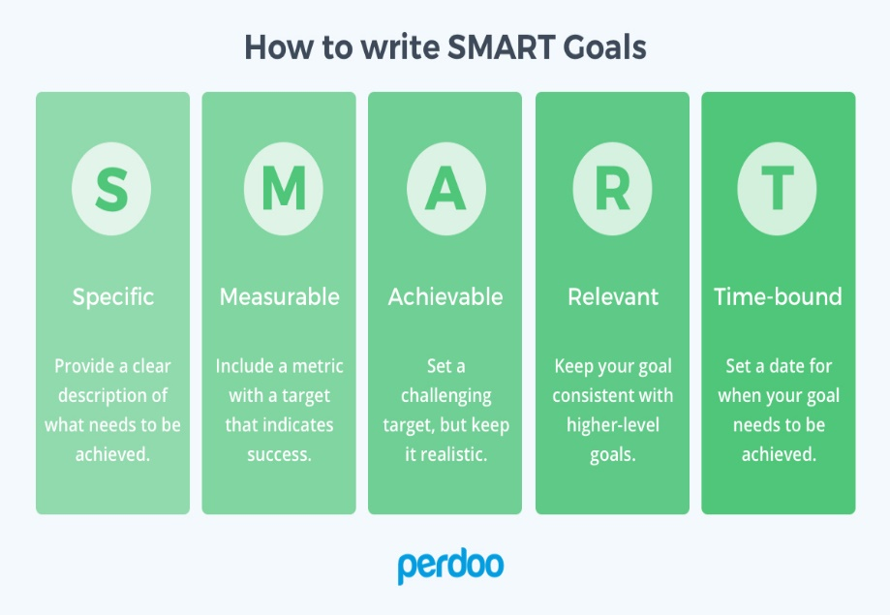](https://www.google.com/url?sa=i&rct=j&q=&esrc=s&source=images&cd=&cad=rja&uact=8&ved=2ahUKEwjD0aj4nsTdAhVUWH0KHT9lCg8QjRx6BAgBEAU&url=https://www.perdoo.com/blog/okr-vs-smart-goals/&psig=AOvVaw0HDURMDdj3V6Uhf6P1kqUy&ust=1537349385631694)**Activity: Making Priorities SMART, Gender Equal and Inclusive**

**Objective:** To make SMART, gender equal, and socially inclusive policy priorities

**Duration:** 1-2 hours

**Materials needed (depending on preference of trainer):** Clipboard paper, markers, pens

1. Divide the participants into groups. Groups should be divided by the different themes of the draft policy. Remind them of the term “policy priority”. (*Reminder:* *a priority is what is important to the common good, or everyone living in a country. For example: Easy access to reproductive health services for young women living in rural areas. Fair wages for migrant workers in Vientiane).*
2. Ask each group to write one priority for their theme. For example:

|  |  |
| --- | --- |
| **Theme** | **Priority** |
| Education | Young men and women will have equal access to sexual and reproductive health education. |

1. After each group has written one priority, ask them to make it Specific. When writing a specific priority, ask them to consider the following questions:
2. *Who do I want to target? (age range, sub-group, gender, etc.)*
3. *Where does my target live? (country, province, city, town, etc.)*
4. *Is the change I want to achieve too vague? How to make it more detailed?*
5. *Is there one sub-population that has a different or particular set of needs?*

|  |  |
| --- | --- |
| **Theme: Education** | |
| **Priority** | **Specific Priority** |
| Young men and women will have equal access to sexual and reproductive health education | Young men and women, ages 18-25 and studying at public universities in Vientiane Capital, will have equal access to sexual and reproductive health education, with particular emphasis on:   * Ethnic minorities * Youth living in rural areas |

1. After each group has written a Specific priority, ask them to make it Measurable. When writing a measurable priority, ask them to consider the following questions:
2. *How many people will the policy target? (How many people will be changed?)*
3. *How many provinces, towns, schools, businesses, etc. will the policy target?*
4. *What other ways can “change” be measured?*

|  |  |  |
| --- | --- | --- |
| **Theme: Education** | | |
| **Priority** | **Specific Priority** | **Measurable Priority** |
| Young men and women will have equal access to sexual and reproductive health education. | Young men and women, ages 18-25 and studying at public universities in Vientiane Capital, will have equal access to sexual and reproductive health education, with particular emphasis on:   * Ethnic minorities * Youth living in rural areas | 25,000 Young men and women, ages 18-25 and studying at public universities in Vientiane Capital, will have completed two courses on sexual and reproductive health education, with particular emphasis on:   * Ethnic minorities * Youth living in rural areas |

1. After each group has written a Measurable priority, ask them to make it Time-Bound.

|  |  |  |  |
| --- | --- | --- | --- |
| **Theme: Education** | | | |
| **Priority** | **Specific Priority** | **Measurable Priority** | **Time-Bound Priority** |
| Young men and women will have equal access to sexual and reproductive health education. | Young men and women, ages 18-25 and studying at public universities in Vientiane Capital, will have equal access to sexual and reproductive health education, with particular emphasis on:   * Ethnic minorities * Youth living in rural areas | 25,000 Young men and women, ages 18-25 and studying at public universities in Vientiane Capital, will have completed two courses on sexual and reproductive health education, with particular emphasis on:   * Ethnic minorities * Youth living in rural areas | 25,000 Young men and women, ages 18-25 and studying at public universities in Vientiane Capital, will have completed two courses on sexual and reproductive health education by 2025, with particular emphasis on:   * Ethnic minorities * Youth living in rural areas |

1. After each group has made their priority Time-Bound, ask them to review it and consider if it is Attainable and Relevant. When considering this, they can think about the following questions:
2. *How can I accomplish this goal?*
3. *How realistic is the goal, based on other constraints, such as financial factors?*
4. Once all of the groups have made their priorities SMART, remind them to make their priorities gender equal and socially inclusive.

|  |  |  |
| --- | --- | --- |
| **Theme: Education** | | |
| **Priority** | **SMART Priority** | **Gender Equal/Inclusive Priority** |
| Young men and women will have equal access to sexual and reproductive health education. | 25,000 Young men and women, ages 18-25 and studying at public universities in Vientiane Capital, will have completed two courses on sexual and reproductive health education by 2025, with particular emphasis on:   * Ethnic minorities * Youth living in rural areas | 25,000 Young men and women (including disabled, LGBTI, and ethnic minorities) ages 18-25 and studying at public universities in Vientiane Capital, will have completed two courses on sexual and reproductive health education by 2025, with particular emphasis on:   * Ethnic minorities * Youth living in rural areas |

These priorities essentially have the targets and indictors “built in” but it is also possible to express the priorities in different ways. In your policy you can choose a format that suits your needs. An alternative was to express this is in the example below:

|  |  |  |
| --- | --- | --- |
| **Theme: Education** | | |
| **Priority** | **Target** | **Indicator** |
| Young men and women will have equal access to sexual and reproductive health education. | Young men and women, ages 18-25 and studying at public universities in Vientiane Capital, with particular emphasis on:   * Ethnic minorities * Youth living in rural areas | 25,000 youth will have completed two courses on sexual and reproductive health education by 2025, including at least 10% of participants   * With disabilities * From LGBT youth * Ethnic minorities |

[](https://www.google.com/url?sa=i&rct=j&q=&esrc=s&source=images&cd=&cad=rja&uact=8&ved=2ahUKEwj2_OHCkOfdAhUYeysKHVQ7CLwQjRx6BAgBEAU&url=https://thenounproject.com/term/checklist/5166/&psig=AOvVaw3t2Spozzls7qGbeYPe_t0x&ust=1538548114819552)**Checklist: Priorities**

|  |  |  |
| --- | --- | --- |
| Item | Yes | No |
| The priorities that have been developed are gender equal, socially inclusive, and SMART |  |  |
| The priorities that have been developed match the overall vision of the policy |  |  |
| The priorities that have been developed pay particular attention to specific youth sub-populations |  |  |
| The threats that may challenge achievement of a particular priority have been considered |  |  |
| Clear responsibilities for who will take the lead on each priority have been assigned/identified |  |  |
| Appropriate indicators for measuring achievement of the policy objectives have been selected and attached to each priority |  |  |

### cid:FD28D003-BCA1-4929-917D-A9729999537D@SSG-140**Validation**

* Finalization of content and structure
* Consensus building
* Endorsement and validation

The final stage of the youth policy development process may require extensive re-examination, as well as consensus building among diverse stakeholders. While this stage could certainly be made easier by ensuring that relevant persons and groups are involved in the development of the policy from the very beginning, the reality is that even towards the end of the process, there will be many policymakers, youth, and other youth stakeholders who still need to understand the policy and may or may not have concerns and suggestions. It is thus important that the validation of a youth policy be inclusive and thorough.

**Content and Structure:** At this stage, the priorities and actions that have been identified and developed, as well as the results of the contextual and situational analyses, can be brought together into a policy document. The content of the document might look like this:

1. *Foreword*
2. *Rationale for the Policy and Definition of Youth and Youth Profile*
3. *Historical and Contemporary issues impacting youth development*
4. *Reference to other policies and documents*
5. *Principles and values supporting policy*
6. *Goals and vision statement*
7. *Policy Objectives*
8. *Rights, responsibilities, and obligations of young men, women, and the different sub-populations within youth.*
9. *Key strategies/policy areas*
10. *Priority target groups*
11. *Implementation and coordination mechanisms*
12. *Provisions for monitoring and participatory evaluation of the policy.*

[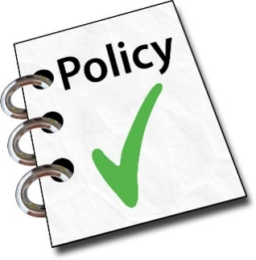](https://www.google.co.th/url?sa=i&rct=j&q=&esrc=s&source=images&cd=&cad=rja&uact=8&ved=0ahUKEwiHxbbZ1MnVAhXMTbwKHbz3DB8QjRwIBw&url=http://www.easpd.eu/easy/content/policy&psig=AFQjCNEg9lzXXo9XovVCJ6xmsFpp7VNHCQ&ust=1502351254965876)

### **Questions to consider**

* Is the current youth policy draft well structured? Does it need to be reorganized?
* What is missing from the draft youth policy?
* Are there any chapters in the youth policy that could be removed or integrating with a different chapter?
* Is there agreement among stakeholders on the vision, content and structure of the policy? If there is disagreement, what needs to be changed?
* Have relevant stakeholders had time to thoroughly review and comment on the youth policy?
* What stakeholders haven’t been consulted in the development of the policy? How can they be involved at this stage?
* What steps need to be taken in order for the policy to be endorsed and validated? What government bodies are in charge of this? What do they require?

**Consensus Building:** Once the draft is developed and reviewed by all stakeholders involved, consultations need to take place with those who have been outside of the process up to this point. Consensus building may require several consultations, and result in several more drafts before a policy is ready to be reviewed and finalized by legislative and executive bodies. It is also important to ensure that the stakeholders have time to adequately review the policy drafts.

**Endorsement and Validation:** Once consensus by relevant stakeholders has been built, the finalized policy can be reviewed and validated by the appropriate legislative and government bodies.

[](https://www.google.com/url?sa=i&rct=j&q=&esrc=s&source=images&cd=&cad=rja&uact=8&ved=2ahUKEwj2_OHCkOfdAhUYeysKHVQ7CLwQjRx6BAgBEAU&url=https://thenounproject.com/term/checklist/5166/&psig=AOvVaw3t2Spozzls7qGbeYPe_t0x&ust=1538548114819552)**What’s in the youth policy?**

Use the checklist below to see what is covered by the youth policy that you are developing:

|  |  |  |  |
| --- | --- | --- | --- |
| **Checklist for Key Items in the Youth Policy** | | | |
| *Item* | | *Yes* | *No* |
| 1 | Coordination mechanism for leading the policy |  |  |
| 2 | Specific responsibilities for government and other stakeholders (including youth) relating to the priorities and objectives covered by the policy |  |  |
| 3 | Priorities that are gender equal, socially inclusive, and SMART |  |  |
| 4 | Indicators that measure change |  |  |
| 5 | Timeframe for implementing and achieving the objectives of the policy |  |  |
| 6 | Rationale and Vision |  |  |
| 7 | Analysis of youth and their needs, including those who are vulnerable |  |  |
| 8 | Definition of target beneficiaries of policy (youth) |  |  |
| 9 | Activities targeting young women and girls |  |  |
| 10 | Activities targeting vulnerable youth |  |  |
| 11 | Monitoring and evaluation system |  |  |
| 12 |  |  |  |
| 13 |  |  |  |
| 14 |  |  |  |
| 15 |  |  |  |
| 16 |  |  |  |

[](https://www.google.com/url?sa=i&rct=j&q=&esrc=s&source=images&cd=&ved=2ahUKEwiR-ZHU5uTdAhUS3o8KHUvJAwgQjRx6BAgBEAU&url=https://mikecavaliere.com/wtf-is-front-end-development/question/&psig=AOvVaw0QJtrauYItCecx-dmst7-h&ust=1538468139504321)**Reflection Questions: Policy Process**

|  |  |
| --- | --- |
| **Question** | **Answer/Comment Space** |
| How does the policy development process of my country compare to the one recommended by this toolkit? |  |
| What agencies can take a leading role in the development of your country’s youth policy? What will be their roles? |  |
| What is the understanding of stakeholders in my country on youth policy development? |  |
| How can vulnerable youth sub-populations and women actively contribute to the policy development process? |  |
| How much time does my country need to effectively develop the youth policy? |  |
| How can I ensure that the opinions of all stakeholders involved in the policy development process (including women and vulnerable youth sub-populations) are equally considered? |  |
| How can I ensure a safe space for vulnerable youth sub-populations to contribute to the policy development process? |  |
| What kind of evidence is needed to inform my country’s youth policy? How can this evidence be gathered? |  |
| What is the capacity of stakeholders in my country to collect qualitative and quantitative evidence on youth issues? |  |

## **next steps: implementation**

As mentioned earlier, some “policies” include actions for implementation, whilst others lay out a strategic direction for which actions still need to be developed. Either way, it is advisable to include an implementation or action plan as part of the youth policy development process, so that implementation is considered at the same time or immediately after the drafting of the policy.

[](https://www.google.com/url?sa=i&rct=j&q=&esrc=s&source=images&cd=&cad=rja&uact=8&ved=2ahUKEwiizJ3C7sjdAhUReysKHcD_CRMQjRx6BAgBEAU&url=https://www.shutterstock.com/search/implementation&psig=AOvVaw146_L_JQ-fWlRioyCpPmHf&ust=1537508191904008)The implementation plan will flow directly from the vision and priorities in the policy. Whilst it is very important that a youth policy and its priorities are realistic and achievable, the means by which they are achieved are equally important. The success of implementation requires resources and expertise, and will be greatly enhanced by inclusive, participatory actions that involve young people in the implementation. The participation of young people will ensure that actions are well targeted and interesting to young people.

The same processes used throughout the policy development phase can be continued or replicated for this phase: there needs to be governance mechanisms, review of the effectiveness of past policy actions, evidence on which to design new actions using the SMART approach, and so on.

### **Governance**

As with the policy phase, an inclusive and participatory approach to coordinating the implementation plan and its delivery is needed. This may be one group bringing together government, youth, and others, it may be multi-layered based on different roles or by the themes in the policy. As the implementation phase extends beyond planning the whole policy cycle, which will be several years, this may need to be a flexible structure, which will allow for turn-over. This group will:

* Lead the development of the implementation plan;
* Oversee the implementation of the actions; and
* Monitor and evaluate progress and adjust actions

The ministry/department responsible for the policy must be the lead or coordinating ministry. Due to the multi-sectoral nature of youth policies, it is important that a cross-ministerial mechanism with representatives from the ministries/departments is part of this structure. Typically, the highest level coordinating body is chaired by the Youth Ministry, has members from 5-6 ministries (health, education, labor, sports, culture, women, etc.), has 2 youth representatives (drawn from a national youth council or other representative body) and representatives from other key groups working with youth (including religious groups). Sponsors and technical supporters are typically ex officio members (including UN agencies).

To ensure a participatory and inclusive mechanism, especially to strengthen outreach to youth, a mechanism to involve more young people is highly recommended.

**Action Planning**

[](https://www.google.com/url?sa=i&rct=j&q=&esrc=s&source=images&cd=&cad=rja&uact=8&ved=2ahUKEwiw3qWPh5zeAhUEFHIKHWdgA8EQjRx6BAgBEAU&url=https://www.muralswallpaper.com/nz/shop-murals/rocket-blueprint-mural-wallpaper/&psig=AOvVaw2TR--jKZjcnffziEaQoQ0_&ust=1540366656252495)The lead agencies responsible for the different components of the policy need to play a leadership role in developing the implementation plan. The action plan will need to consider how each policy objective can be achieved and what is needed to implement, including resources, environment and capacity. As much of the ground work will have been done during the policy development phase (collecting evidence, consultation, etc.), this phase will build on this by designing activities to achieve each objective.

There should be a mix of general activities (for all youth) and targeted activities (for youth with specific needs). This second part is critical to ensure that activities not only benefit middle class urban youth, but youth from all types of social, economic and geographical situations.

Each action needs to be assigned actions with timeframes, resources and responsibilities. For example: the youth policy includes the priority “*by 2010, provide improved access to educational opportunities for young men and women aged 16-18, especially for school drop-outs, youth living in remote areas and disabled youth*.” This might be translated into the following actions:

1. Provide 20,000 additional places in senior high schools by 2030, with at least 50% of these being in rural and remote areas
2. Establish two new vocational colleges in the two provinces with least opportunities by 2025.
3. Develop a national strategy on education for youth with disabilities by 2020.

You can go back and review the policy objectives: do the actions contribute to the objective? Do the actions fulfil all parts of the objective? In this case they match, but there is no action to support educational opportunities for school drop-outs, so it would need to be revisited. Are there specific needs for young women? This might also be considered as a specific action.

As with the policy objectives, check that the actions are SMART (see xxx).

Next, the lead ministry will need to estimate the budget needed. A concrete action like 20,000 additional school places can be translated into a budget relatively easily. However, the availability of funds is critical to coming up with an achievable plan, so developing the budget also needs to include negotiation with the responsible agencies to allocate this funding.

Finally, the responsible agency needs to be assigned. The partners they will work with can also be assigned. An example of this can be found in the table below:

|  |  |  |
| --- | --- | --- |
| **Action** | **Lead Agency** | **Partners** |
| 1 | Ministry of Education | Provincial Governments |
| 2 | Ministry of Labour | Ministry of Education, Trade Unions, Provincial Governments |
| 3 | Ministry of Education | Ministry of Social Affairs, UNICEF, National Disability Forum |

Once each component of the implementation plan is developed, they should be reviewed as a package to check the linkages and synergies within them. For example, education and employment are likely to have strong connections. Involving relevant stakeholders in this phases is also a useful way to build synergies with activities by community organisations and youth themselves.

Finally, and quite critically, the responsible ministries need to integrate these elements into their own forward planning mechanisms. This may take some time, depending on the planning cycles in place.

**Advocacy**

[](https://www.google.com/url?sa=i&rct=j&q=&esrc=s&source=images&cd=&cad=rja&uact=8&ved=2ahUKEwjy3f6G_cjdAhXTbisKHfdfCPcQjRx6BAgBEAU&url=http://caras.org.uk/what-we-do/advocacy/&psig=AOvVaw30eBkMcDzLYJFJvaVG8KHO&ust=1537512043212008)Youth policies are roadmaps for government to guide their action for and with youth. Usually they are also vehicles to facilitate engagement and participation of young people as well. They often have a third target, the wider community, in garnering their support and acknowledgement of young people in their communities. Making sure these people know about the policy, is therefore important to its effective implementation.

One of the most common concerns raised during youth policy consultations by both decision-makers and youth is that awareness of the policy is low. It is critical that the implementation plan includes an advocacy plan, with specific actions and resources to enable implementation. Youth can play a key role in this process as they have the best networks with other use. Involving them in the development and implementation of the advocacy plan is an effective approach to strengthening the advocacy.

**Capacity Building**

You will probably find at some stage during the policy and implementation plan phases that some of the things you want to achieve require expertise and skills that may not be available. This could be for government officers in technical roles, or it could be for youth that you want to partner with in delivery of a project. Identifying these capacity gaps and planning to address this should be included as actions in the implementation plan.

Sometimes you may not anticipate all of the capacity needs in advance. For example, you find that the policy is still not well known after one year and decide to involve youth in a social media campaign promoting the policy. Whilst they might have social media skills, they might not know how to use them in the most effective way.

**Monitoring and Evaluation**

The policy framework sets out a series of measurable objectives, the action planning will similarly set out measurable activities. The monitoring plan should include indicators, targets and means of evaluation. Alignment with national development strategies provides both a clear role for the youth policy in the national agenda and simplification of the logistics needed to collect data (though disaggregation for youth will be needed).

[](https://www.google.com/url?sa=i&rct=j&q=&esrc=s&source=images&cd=&cad=rja&uact=8&ved=2ahUKEwjFvZHiipzeAhXObisKHSr-C8oQjRx6BAgBEAU&url=https://pcdnetwork.org/event/gis-for-monitoring-and-evaluation-course-2/&psig=AOvVaw0NG6VA5s6T_V8G68EJmjOj&ust=1540367636106729)The policy objectives set out “big picture” changes we want to achieve, such as reducing the number of unemployed youth. These are typically measuring social change and can often be monitored through national statistics (means of evaluation). However, inclusive objectives may be more difficult to monitor. For example, if the objective was to reduce youth unemployment by 50% with emphasis on providing employment opportunities for migrant youth, national statistics probably allow us to look at youth as a whole, but might not enable disaggregation by different groups within youth. The monitoring and evaluation plan will need to take this into account. Big picture monitoring is normally done on longer timeframes (every few years), typically at the midpoint and end point of the policy.

The implementation plan will provide a set of focused activities, such as establishing a national youth council. These are typically measured by documenting the actions we undertake, such as minutes of the first meeting of the Council (means of evaluation). Since the achievements are based on things we do, they are generally easier to monitor; either we did it or not. Activity monitoring is generally done as we implement and should be reported on biannually (or at least annually).

There are also elements around the supporting mechanisms that you may want to evaluate: how effective were the advocacy activities; did the capacity building provide the skills we needed for the activities, did the governance structure ensure buy in of the critical stakeholders? These can be very useful in understanding how to adjust the processes supporting the policies implementation if problems occur, and for designing the next policy phase.

The level of monitoring also needs to be considered as well as the transparency of the process. The level of the monitoring may vary depending on what it is we want to know but can include elements at national level, provincial level, and district level. Enabling civil society and youth groups (as rights-holders) to participate in the evaluation process, enables feedback from these groups as the target beneficiaries and an important element in knowing how youth respond to the actions. It also ensures accountability in the process.

## **resources and handouts**

________________________________________________________________________________________________________

**Resources**

* **Youth Policy and Other Guidelines**
* **Youth Policy Toolbox:**Youth Toolbox acts as a repository of knowledge, experiences, and good practices, with the aim of providing policymakers with a comprehensive resource facility for developing inclusive and responsive youth policies in a process that optimizes engagement of youth-led organizations. It strives to engage the participation of a range of stakeholders, increasing the amount and diversity of knowledge and views.

*Author:* United Nations Economic and Social Commission for Asia Pacific

*Year Produced:* 2017

Link: <https://yptoolbox.unescapsdd.org>

* **Youth Policy Manual: How to Develop a Youth Strategy:** The Youth Policy Manual aims at providing concrete and useful information on how to develop a national youth strategy. It presents examples of how young people can be involved both in the development and the implementation of the strategy, and provides an overview of how European institutions, as well as the United Nations, work in the youth policy field, and whether it is relevant to speak of a European standard of youth policy. The manual also suggests a model for how a national youth strategy can be developed from start to finish.

*Author:* Council of Europe

*Year Published:* 2009

*Link:* [https://pjp-eu.coe.int/documents/ 1017981/7110707/ YP_Manual_pub.pdf/ 7b17e1e6-e8b6-4041-902e-3b3ad0973c45](https://pjp-eu.coe.int/documents/%201017981/7110707/%20YP_Manual_pub.pdf/%207b17e1e6-e8b6-4041-902e-3b3ad0973c45)

* **Baku Commitment to Youth Policies:** The [Baku Commitment on Youth Policies](http://youthpolicyforum.org/documents/commitment.pdf), which was agreed to by participants of the UN Global Forum on Youth Policies in 2014, highlights the principles to guide formulation, implementation and evaluation of youth policy in the 21 century. It calls for greater youth involvement in youth policy monitoring and evaluation.

*Author:* United Nations

*Year Produced:* 2014

*Link:* <http://www.un.org/youthenvoy/wp-content/uploads/2014/10/Baku-commitment.pdf>

* **An Introduction and Context for the Development of Youth Policy: A Guide for Local Government:** The Ministry of Youth Development of New Zealand published a guide on how councils can develop a youth policy in their area. This guide is to inform the work of local government and youth councils in working with young people.

*Author:* Ministry of Youth Development of New Zealand

*Year Produced:* 2009 (?)

*Link:* <http://www.myd.govt.nz/resources-and-reports/publications/youth-policy.html>

* **What Works in Youth Participation: Case Studies from Around the World:** What Works focuses on youth participation as a critical factor in positive youth development. It offers nine case studies by youth and adult authors from around the world, including Argentina, Germany, the Philippines, and Thailand. The What Works series examines cutting-edge issues in the youth development field and aims to provide practitioners, policy makers, donors, and others supporting youth initiatives with insights into effective practices and innovative approaches.

*Author:* International Youth Foundation

*Year Produced:* 2002

*Link:* <https://www.iyfnet.org/library/what-works-youth-participation-case-studies-around-world>

* **The EquiPP Manual:** This manual outlines a framework to support equitable and inclusive policy processes, in order to promote greater equity and social inclusion in policy and practice.

*Author:* The Centre for Global Health, Trinity College Dublin

*Year Produced:* 2016

*Link:* <https://global-health.tcd.ie/assets/doc/The%20EquIPP%20manual%2013th%20April%202016.pdf>

* **National Youth Policies (Regional and Global Examples)**
* Cambodia (2011): <http://www.youthpolicy.org/national/Cambodia_2011_Policy_Youth_Development.pdf>
* Philippines (2017): <http://nyc.gov.ph/pydp/>
* Timor-Leste (2016): <https://timor-leste.unfpa.org/en/publications/national-youth-policy-nyp-2016>
* Roma Youth Action Plan (Europe) (2011): <https://rm.coe.int/168046d02c>

**____________________________________________________**

**Activity Handouts**

## **Basic Guide For youth-led research proposal**

**11 Basic Questions:**

1. Who are the young people I want to interview? (Age, background, gender, etc.)
2. What do I want to know about these youth? (What is my BIG research question)?
3. What questions will help me answer the BIG research question? Are they qualitative or quantitative?
4. Where will I find these youth? How will I find them? Who will help me find them?
5. How will I travel to interview the youth?
6. How many researchers are needed in my team? What are their roles?
7. When will I interview these youth?
8. How will I interview these youth? (Online, paper, mobile survey; group or individual interviews)
9. How much will my research cost? What do I need? Why?
10. What are the questions I want to ask the youth?
11. What are the risks and challenges of interviewing these youth? How will I resolve these challenges?

**Sample Strategy**

|  |  |
| --- | --- |
| **Research on Visually Impaired Youth in Chiang Mai** | |
| Big Question | Are visually impaired youth in Chiang Mai getting good health services? |
| Target population | 30 blind youth (male and female) in 3 districts in Chiang Mai ages 18-30 |
| Location | 3 districts in Chiang Mai Province |
| Time | 10 days (April-May 2018) |
| Number of researchers | 3 |
| Responsibilities of researchers | Researcher 1: Travel to Chiang Mai and interview District 1  Researcher 2: Travel to Chiang Mai and interview District 2  Researcher 3: Travel to Chiang Mai and interview District 3 |
| Methodology | Group interviews; qualitative and quantitative |
| Budget | $1,120 USD (Details below) |
| Research Contact persons | Ministry of Health |
| Risks and Challenges and Solutions | Risk #1: Ministry of Health won’t speak to me.  Solution #1: Speak to National Youth Council |
| Supporting Questions (Example) | 1. How old are you? 2. Where do you live? 3. Are you male, female, or other? 4. How long have you been blind? 5. Have you ever received health services? For what? Where? 6. Can you easily access health services in Chiang Mai? Why or why not? |

**Make a Research Plan (Example)**

|  |  |  |  |  |  |  |  |
| --- | --- | --- | --- | --- | --- | --- | --- |
| **Activity** | | **Month/Date (2018)** | | | | | |
| Feb | Mar | Apr | May | Jun | Jul |
| 1 | Submit and revise first draft data strategy/plan for data collection |  |  |  |  |  |  |
| 2 | Submit and revise final draft data strategy/plan for data collection |  |  |  |  |  |  |
| 3 | Submit budget for data strategy to UNESCO |  |  |  |  |  |  |
| 4 | Receive money from UNESCO for data collection |  |  |  |  |  |  |
| 2 | Travel to Chiang Mai |  |  |  |  |  |  |
| 3 | Collect data in District 1, Chiang Mai (Health centers) |  |  |  |  |  |  |
| 4 | Collect data in District 2, Chiang Mai (Government office) |  |  |  |  |  |  |
|  | Collect data in District 3, Chiang Mai (Schools) |  |  |  |  |  |  |
| 5 | Submit first draft data to UNESCO |  |  |  |  |  |  |
| 6 | Analyze data at workshop in Bangkok |  |  |  |  |  |  |
|  | Submit proposal for presenting data and finalize data analysis |  |  |  |  |  |  |

**Make a Research Budget (Example)**

|  |  |  |  |
| --- | --- | --- | --- |
| **Activity** | | **Cost** | **Comment** |
| 1 | Travel | 300 USD | 100 USD x 3 people |
| 2 | Accommodations | 360 USD | 12 USD x 2 people x 10 nights |
| 3 | Per diem | 300 USD | 10 USD x 3 people x 10 days |
| 4 | Interview fees | 100 USD | 50 USD x 2 days x 1 guide |
| 5 | Local Transportation | 60 USD | 10 USD x 3 people x 2 days |
| **Total** | | 1,120 USD |  |

**From Vision to Priorities:**

**A Guide to Articulating a Policy Vision and Making Recommendations**

**UNESCO Bangkok**

**Step 1: Writing Your Vision for the Future**

At this time, you have already decided what your vision is for the future. You have done this by making a model. But now, you need to say what your vision is with **words,** not pictures. How do you do this?

Look at your model. Every part of your model has a meaning. In the table below, can you describe all the parts of your model and their meaning?

|  |  |
| --- | --- |
| **Model Part** | **Description/Meaning** |
| *Example: Phone/Tablet* | *Example: An app where young people can find health care providers at different locations and ask to meet with them.* |
| *Example: Health Center with many doors* | *Example: A health center where young people can enter at different locations for privacy.* |
|  |  |
|  |  |
|  |  |
|  |  |
|  |  |
|  |  |
|  |  |
|  |  |
|  |  |

You have now turned your model into written sentences. However, this is too much detail! Visions for the future must be short sentences that are not too detailed.

Look at the meanings/descriptions of your model that you have written down. Try to find common ideas/themes. Make a list of these ideas/themes. This is very similar to the coding you are doing with qualitative research analysis. For example:

|  |  |
| --- | --- |
| **Description** | **Ideas/Themes** |
| *An app where young people can find health care providers at different locations and ask to meet with them.* | * Accessibility (easy to have) * Privacy * Personal |
| *A health center where young people can enter at different locations for privacy.* | * Privacy * Safety |

You now have several ideas/themes that relate to the meanings of the model you made. Now you can make a vision statement that is 1-2 sentences. For example:

*Youth in Lao PDR should have the right to have health care that is* ***easily accessible*** *and* ***personalized*** *without fearing for their* ***safety*** *or* ***lack of privacy****.*

GENDER EQUALITY AND SOCIAL INCLUSION: Please do not forget to make your visions gender equal and socially inclusive of many youth in Lao PDR. For example:

*Youth in Lao PDR should have the right to have health care that is* ***easily accessible*** *and* ***personalized*** *without fearing for their* ***safety*** *or* ***lack of privacy****.*

*All youth in Lao PDR, regardless of gender, should have the right have health care that is easily accessible and personalized without fearing for their safety of lack of privacy*

**Step 2: Making Your Vision into Policy Priorities**

A **priority** is something that is important to you. You may have many *personal priorities,* such as “I will go to university,” or “I will find a good job,” or “I will get married.”

A **policy priority** is something that is important for the common good (everyone). For example:

* School facilities are safe and accessible.
* Male and female secondary students are graduating at the same rates.
* Schools are preparing students for gainful employment.
* Schools are inclusive of youth from all backgrounds.
* Scholarships are available to youth in need.

A policy priority should link/match with your vision.

|  |  |  |
| --- | --- | --- |
| Theme | Vision | Priorities |
| Health | All youth in Lao PDR, regardless of gender, should have the right have health care that is easily accessible and personalized without fearing for their safety of lack of privacy | 1. Hospitals are accessible to rural youth; 2. Young men and women are receiving education on Sexual and Reproductive Health; 3. Young men and women can afford treatment; |

As you can see, two of the priorities are related to accessibility, but none are related to privacy or personalization. If you think that your priorities do not match your vision, try to write more priorities that DO match your vision.

Now try to practice writing your own priorities!

|  |  |  |
| --- | --- | --- |
| Theme | Vision | Priorities |
|  |  |  |

1. The definition of youth is often ambiguous and changes depending on the country and international agency. Typically, youth can include anyone between the ages of 15 and 30. UNESCO’s definition can be found in the Glossary section of this Toolkit.
2. “Youth 2030: Working with and for Young People.” The United Nations. 2018. P. 10. <https://www.un.org/sustainabledevelopment/wp-content/uploads/2018/09/18-00080_UN-Youth-Strategy_Web.pdf>
3. “Exclusion.” UNESCO. 2016. <http://www.unesco.org/new/en/social-and-human-sciences/themes/international-migration/glossary/exclusion/>
4. Denstad, Finn Yrjar. “How to Develop a National Youth Strategy.” Council of Europe Publishing, 2009. <https://pjp-eu.coe.int/documents/1017981/7110707/YP_Manual_pub.pdf/7b17e1e6-e8b6-4041-902e-3b3ad0973c45>
5. UNDP. *Youth and Democratic Citizenship in East and Southeast Asia: Exploring Political Attitudes of East and Southeast Asian youth through the Asian Barometer Survey.* August, 2014. UNDP. <http://www.asia-pacific.undp.org/content/dam/rbap/docs/Research%20&%20Publications/democratic_governance/RBAP-DG-2014-Youth-n-Democratic-Citizenship-East-n-SE-Asia.pdf>
6. Hart, Roger A. “Children’s Participation: From Tokenism to Citizenship.” Innocenti Essays, Volume 4. UNICEF. 1992. <https://www.unicef-irc.org/publications/pdf/childrens_participation.pdf>
7. “Participation Models: Citizens, Youth, Online: A Chase Through the Maze, 2nd Edition.” Creative Commons. 2012. <https://www.nonformality.org/wp-content/uploads/2012/11/Participation_Models_20121118.pdf>